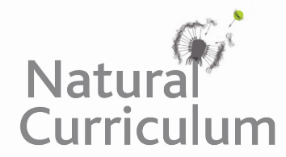
Learning Objective
We are learning how to use commas to clarify meaning and avoid ambiguity when writing sentences about humpback whales.

Challenge 1
Draw a picture to show the meaning of the sentences below:

1A) I love my parents, the humpback whale and David Attenborough. | 1B) I love my parents the humpback whale and David Attenborough.
2A) “Let’s eat grandpa,” said the ravenous humpback calf. | 2B) “Let’s eat, grandpa,” said the ravenous humpback calf.

Challenge 2
Read the sentences below and decide where the commas should go.

- The pectoral fins of a humpback can grow to nearly five metres long making them the longest flippers of any baleen whale.
- A humpback’s diet mainly consists of krill but it will also eat small schooling fish such as anchovies sardines and mackerel.
- Humpbacks are baleen whales which means that they have a specialised filter feeding system inside their mouth.
- During the whaling era when whale blubber was turned into oil humpbacks nearly became extinct.
- Since the ban on commercial whaling in 1985 humpback whale numbers have increased.
- Humpback whales are known for their haunting songs which consist of a sequence of grunts moans howls and cries.
- When a tiger shark swam close by marine biologist Nan Hauser was protected by a humpback whale which nudged her body out of danger.

