Learning Objective
We are learning how to write sentences about king cobras that contain a relative clause.

Challenge 1
Highlight all of the relative clauses in the paragraph below. (A relative clause is introduced by one of the following relative pronouns: who, which, that, whose and whom.)
After hearing her dog bark, the little girl, who had been playing in her back garden, spotted the king cobra. Scared, she raced inside to alert her parents. Her mother phoned the snake conservation team, who were based in the next town. When they arrived, the cobra, which was three and a half metres long, was safely bagged and boxed. Before being released into the wild, the snake was given a thorough health check by Colin, who was very relieved that he had managed to save yet another snake from certain death.

Challenge 2
Combine each of the two sentences below to make a single sentence that contains a relative clause. e.g. The king cobra is renowned for its impressive size. The king cobra can reach almost six metres in length. The king cobra, which can reach almost six metres in length, is renowned for its impressive size.

- The cobra spread its hood. The cobra was feeling threatened.
- The cobra growled like a dog. The cobra was feeling threatened.
- Cobras are even known to eat their own kind. A cobra’s diet mainly consists of snake.
- Male king cobras wrestle each other during the breeding season. They do not bite each other as they are immune to their own venom.
- The king cobra laid her eggs. The king cobra’s nest was made from leaves.

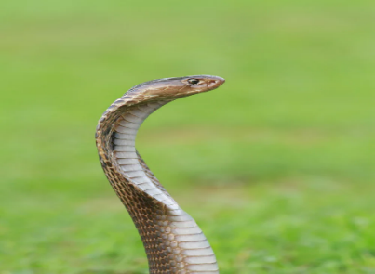
Challenge 3
Imagine that you discover a king cobra in your garden that has escaped from a local zoo.

Write about this discovery and include details of the snake’s behaviour, how you reacted to it and how it was removed. Include three sentences that contain a relative clause. Try to use different relative pronouns and include some of the descriptive words from the Word Wall.

whom
inflated
assessed
deadly venom
that
whose
who
which
anaesthetised
Thailand
bagged
released
Word Wall
king cobra

