Learning Objective
We are learning how to use and punctuate direct speech.

Challenge 1
Someone has forgot to put the inverted commas (speech marks) around the spoken words in the sentences below. Can you put them in the right places?

- I can’t believe he just tried to slap me with his flippers! exclaimed the startled researcher.
- That nest is definitely lacking in rocks, said the unimpressed female.
- Looking back at the breeding ground, the eldest chick said, It will be a long time before we return here.
- The concerned Adélie shouted in panic, Quick! There’s a leopard seal heading our way!
- That was amazing! said the diver as he resurfaced. I’ve just watched an Adélie swallow a jellyfish.
- I can’t compete with an Adélie penguin said Tom Daley, it can dive to a depth of 180 metres.

Challenge 2
Complete the passage below by writing the spoken words of Arwel and Amos. Don’t forget to start your spoken words with a capital letter, finish with the correct ‘end’ punctuation mark and enclose them with inverted commas (speech marks).

To cheer up his best friend, Amos collected some small rocks from his own nest and dropped them next to Arwel.
________________________________________ whimpered Arwel, wiping away his tears with a flipper.
Suddenly, Amos, who had always wanted to be a detective like the great Sherlock Holmes, had an explanation for the mystery of the disappearing stones. _______________________________________ suggested Amos as he scoured the colony with his beady eyes.
______________________________________ replied Arwel. Within seconds Arwel was back on his feet and examining other nests within the colony for any sign of his stolen treasure. He didn’t need to look far. _____________________________ shouted Arwel as he squared up to the thief.
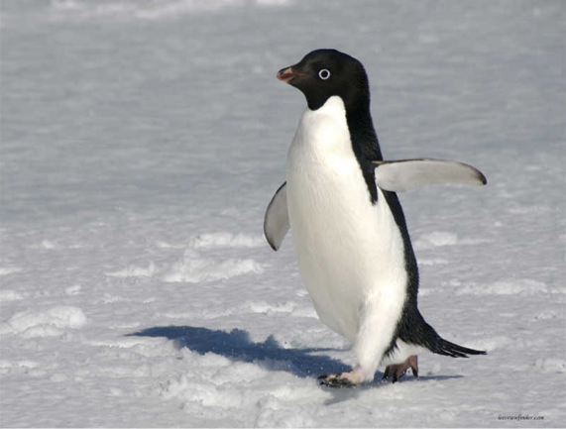
Word Wall
Challenge 3
Arwel thinks he has found the thief! His next door neighbour, Ralph, appears to have more than his fair share of rocks in his nest. Arwel is certain that some of them are the ones he had collected. Will Ralph own up to the crime? Will Amos come up with a solution? Write a conversation between the three Adélie penguins that uses direct speech and some of the descriptive words from the Word Wall.
Adélie
Antarctica
property
collected
criminal
neighbour
impressive
colony
robber
puzzled

