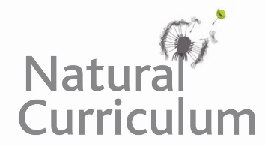
Learning Objective
We are learning how to demarcate sentences with capital letters, full stops, question marks and exclamation marks.

Challenge 1
Correct the sentences below:
- an adult harvest mouse is tiny and can weigh as little as a 2p coin___
- what a tiny creature the harvest mouse is ___
- what does a harvest mouse usually eat ___
- it is mainly vegetarian , eating seeds and fruits, but will also eat invertebrates ___
- join the Wildlife Trust to help protect the harvest mouse’s habitat___
- how can you identify a harvest mouse___
- the harvest mouse has pale ginger or yellow fur and a hairless tail which is nearly as long as its body___
- how long its tail is ___

Challenge 2
Read the following statements about the harvest mouse. Underneath, write a question/ command/ exclamation using the information in the statement to help. Remember your punctuation! An example is given below.

Statement: The harvest mouse has a prehensile tail which is used to help it climb.
Question: Which special feature helps the harvest mouse to climb?

- Statement: Harvest mice have many predators such as weasels, stoats, foxes, owls and hawks.
Question:

- Statement: The harvest mouse is only 5-7 cm long.
Exclamation:

- Statement: The population of harvest mice is believed to be in decline as a result of habitat loss and farming methods.
Command:

- Statement: Harvest mice are less active in winter but do not hibernate as they stay close to the ground and store food carefully.
Question:

Challenge 3
You have been asked to rewrite the script for Sir David Attenborough to read in his narration of this clip. You will need to use the full range of sentence types to keep the audience entertained and build up suspense as the owl comes in to view. You could use some of the descriptive words from the Word Wall and any of the additional facts from the activities above to help.

