Learning Objective
We are learning how to use and punctuate direct speech.

Challenge 1
Someone has forgotten to put the inverted commas (speech marks) around the spoken words in the sentences below. Can you put them in the right places?

- I can’t believe you think you’re bigger than me! exclaimed Carlos.
- I think we’re going to have to work together, said the soft-bodied hermit crab.
- Unless we find someone big enough, one hermit said, then there’s no way our shell exchange will work.
- Sizing up against another hermit, the aggressive crab said, Oi! You think you’re big and tough, do you?
- Let’s be positive! said one optimistic hermit. If we work as a team, I’m confident we will be successful.
- Well this is all well and good, said one disgruntled hermit crab, but I think I preferred my last home.

Challenge 2
Complete the passage below by writing the spoken words of Alya and Carlos. Don’t forget to start your spoken words with a capital letter, finish with the correct ‘end’ punctuation mark and enclose them with inverted commas (speech marks).

Pleased with her new shell, Alya strutted along the shore, admiring her new home and its roomier feel.
________________________________________ Alya asked Carlos, smiling broadly.
Unenthusiastically, Carlos looked at Alya’s shell.
_______________________________________ sighed Carlos, as a look of disappointment spread across his face.
______________________________________ replied Alya. She began to scurry across the shore, searching for a new shell her friend could enjoy. Suddenly, she spotted something perfect. _____________________________ exclaimed Alya, as she ran towards it, followed by a gloomy Carlos.

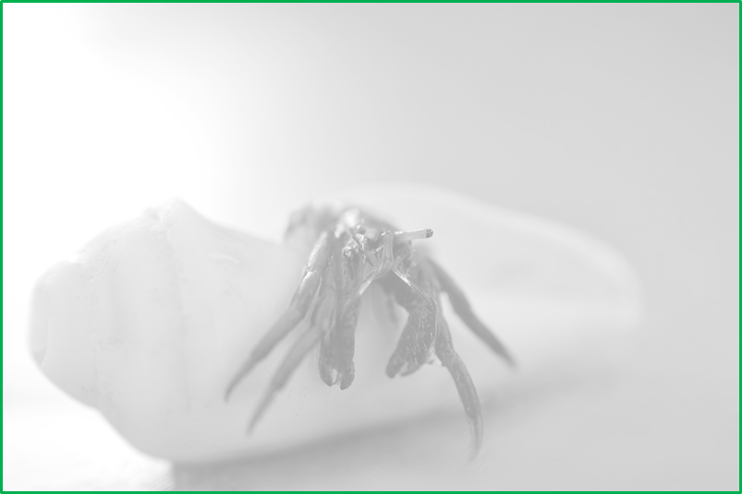
Challenge 3
Using your response in Challenge 2, continue the story of what happened with Carlos and Alya! What has Alya spotted that might cheer Carlos up? Will he agree that this is the solution to his problems? Write a conversation between the hermit crabs that uses direct speech and some of the descriptive words from the Word Wall.
compared
measured

orderly
upgrade
impressive
arranged
together
organised
patiently
rocky shore
Word Wall

