Learning Objective
We are learning how to write sentences in both the simple past tense and its present perfect form.

Challenge 1
Complete the following simple past tense sentences with the correct verb from the list below.
bared
entered
stole
emptied
heard
outnumbered
swung

- The gang of macaques ____________ swung from the power-lines.
- The devious monkeys_____________ fruit from the market stall.
- The thieves ____________ the building through the shuttered window.
- Within the troop, the females ______________the males.
- The higher-ranking male _________________ its teeth at the lower-ranking male.
- The screeching of the aggressive macaque could be ____________ all over the city.
- The greedy primate ______________ the fridge of its contents.

Challenge 2
Rewrite the following sentences in the past tense using the present perfect form. Remember - in the present perfect, a sentence must include the word ‘has’ or ‘have’ and the main verb (bold) must end in –ed (unless it is an irregular verb).

- The film crew are following the monkeys through the colourful city.
e.g. The film crew have followed the monkeys through the colourful city.

- I am hiding the fruit from the thieving monkeys.
- The destructive macaques are ransacking the house.
- The crafty macaques are grabbing whatever they can from the market stalls.
- The macaques are stealing fruit again!
- The ageing macaques are living in the grounds of the Red Fort.

Now use your editing skills to add an additional word to each sentence to make it more descriptive.

Challenge 3
Using some of the descriptive words from the Word Wall, see if you can write your own sentences about the rhesus macaques featured in the film clip. Try to include a mixture of sentences that are in the simple past tense and its present perfect form. Don’t forget to include the word ‘has’ or ‘have’ in each sentence.
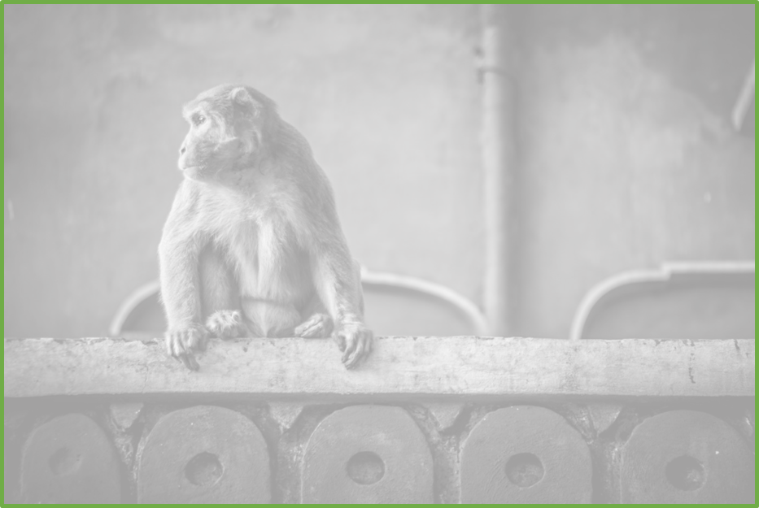
Word Wall
destructive
criminal
lookout
rhesus macaque
troop
gang
raided
tangled wire
leapt
bounded
adaptable
ransacked

