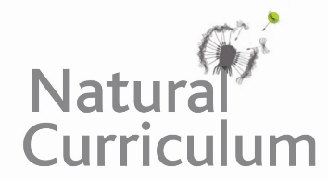
Learning Objective
We are learning how to organise paragraphs around a theme.

Challenge 1
Under the title Animals That Shed Their Outer Layer, cut out and organise the sentences below into four clear paragraphs before sticking them into your book.

Challenge 2
Before you stick the sentences into your book, give each paragraph a subheading.

Challenge 3
Once you have completed challenges 1 and 2, write your own concluding paragraph.

There is no need to be alarmed as new human cells quickly replace the old ones.
In the animal kingdom, there are many animals that cast off their outer layer or covering.
Some reptiles will eat their skin as it is rich in nutrients.
When a snake sheds its skin, it is rather like removing a sock!
As a result of this, the birds must look for a safe place to hide from predators during the moulting period.
This is called shedding or moulting, and it usually takes place at a particular time of year or stage in an animal’s life cycle.
Birds must shed any old and worn feathers before they can be replaced by new ones.
It’s hard to believe, but even humans shed skin!
Some even become flightless during moulting.
Lizards and snakes shed their skins so that they can grow.
Scientists have estimated that every day a human will lose a million skin cells (30,000 - 40,000 every hour).

