Learning Objective
We are learning how to start sentences in a variety of interesting ways.

Challenge 1
Using link lines, match each sentence starter to the correct sentence ending.

Watching the footage on the camera traps, |  | the feral pigs munched their way through the fallen fruits.
Carefully, |  | the cassowary returned her egg to the hollow scrape in the ground.
Growing to a height of one and a half metres, |  | the cameraman retreated to the safety of his hide.
Worried that the protective mother could turn on him, |  | the scientists were alarmed by the great number of feral pigs roaming in the forest.
Protecting Australia’s native wildlife |  | cassowaries have been described as ‘one of the world’s most dangerous birds.'
Noisily and greedily, |  | must involve stopping the spread of feral pigs.

Challenge 2
Complete the following sentences. Notice how they all start in a really interesting way.

- Amazed by the sight of the cassowary, ___________________________________
- Cautiously, the camera crew ____________________________________________
- As quick as lightning, _________________________________________________
- Rooting around for fallen fruit, _________________________________________
- Grunting and snorting, ________________________________________________
- Equipped with enormous claws on each foot, ________________________________
- Like a digger on a building site, __________________________________________

Challenge 3
Write a descriptive story opening that describes the Australian rainforest featured in the film clip and some of the animals found there. Don’t forget to describe through your senses and experiment with a range of interesting sentence starters (see below). Try also to use some of the descriptive words from the Word Wall.
Interesting sentence starter reminder:
- Start with an ‘ed’ or ‘ing’ ending verb
- Start with a ‘ly’ ending adverb
- Start with a simile

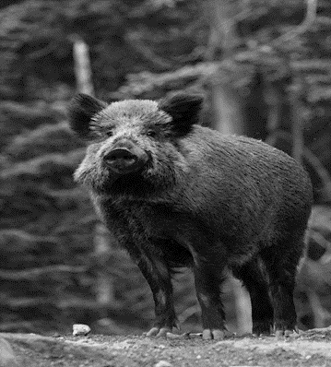
Word Wall

cassowary
ancient rainforest
uprooting
munching
foraging
cautiously
curiously
protectinge
feral pig

