Learning Objective
We are learning how to use prepositions to show a relationship, typically in terms of place or time, between two or more things, people or events.

Challenge 1
Complete the following sentences by choosing the most appropriate time, place or direction preposition from the list below
before
beside
around
through
after
on
across

- The agile primate made his way _____ the trees.
- The young gibbon tried to keep his balance by standing _____ a branch.
- If another gibbon gets in his way, the primate will have to move _____ him.
- If there is a river running through the rainforest, the monkey must manoeuvre through the trees to get _____ it.
- The young gibbon played _____ his friend.
- The determined primate prepared himself _____ he leapt from the branch.

Challenge 2
Using a preposition from the list below, write a sentence about each image that explains where a gibbon is, either in relation to another gibbon or its surroundings.
below
beside
beneath
above
across
between
along
next to
amongst

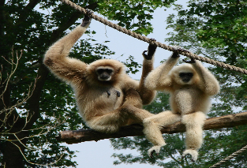
- _______________________________________________

_______________________________________________

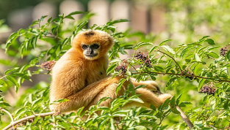
- ______________________________________________
Snow leopard
______________________________________________
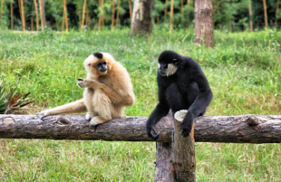
- ______________________________________________

______________________________________________
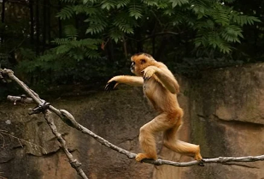
- ______________________________________________

______________________________________________
Word Wall
won’t
territory
Snow leopard
won’t
won’t
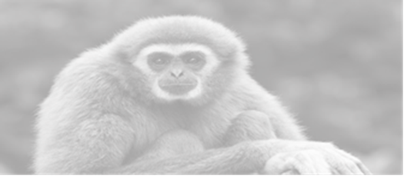
Challenge 3
Using some of the prepositions and descriptive words from the Word Wall, write your own scintillating sentences about the gibbons featured in the film clip.
during
gibbon
before
inside
rainforest
leapt
agile
canopy
beneath
towards
acrobat
long-limbed
somersaulted
behind

