Learning Objective
We are learning how to use commas after fronted adverbials

Challenge 1
Using link lines, match each fronted adverbial to the correct main clause.

As the temperature plummeted,
As gunfire echoed around the mountains,
In the land of the volcanoes,
Deeply suspicious of the advancing humans,
When the stranger approached,
Hungrily,
the new born baby was stripping and eating the bamboo shoots.
the silverback let out a deafening roar.
the gorillas disappeared into the undergrowth.
the frightened gorillas scattered.
the mountain gorillas huddled together for warmth.
Titus, the oldest silverback in the world, was king.

Challenge 2
Rewrite the sentences below so that the adverbial phrase is at the front, separated from the rest of the sentence by a comma.

1) The gorilla ate leaves and shoots all day long.
______________________________________________________________________

2) The gorillas started to make their nest an hour before sunset.

______________________________________________________________________

3) Titus, the legendary silverback, fathered many children throughout his life.

______________________________________________________________________

4) The intimidating male beat his chest repeatedly.

______________________________________________________________________

5) The infant approached the cameraman with great curiosity.

______________________________________________________________________

6) The male started to develop a silver section of hair over his back from the age of twelve.

______________________________________________________________________
Challenge 3
After 3 days of your guide hacking a way through the Bwindi Impenetrable National Park, you finally encounter a troop of mountain gorillas. Write about this once-in-a-lifetime experience using some of the descriptive words from the Word Wall. Try to include at least 3 sentences that start with a fronted adverbial. (Remember – fronted adverbials give the reader information about when, how, where and how often an action took place.)
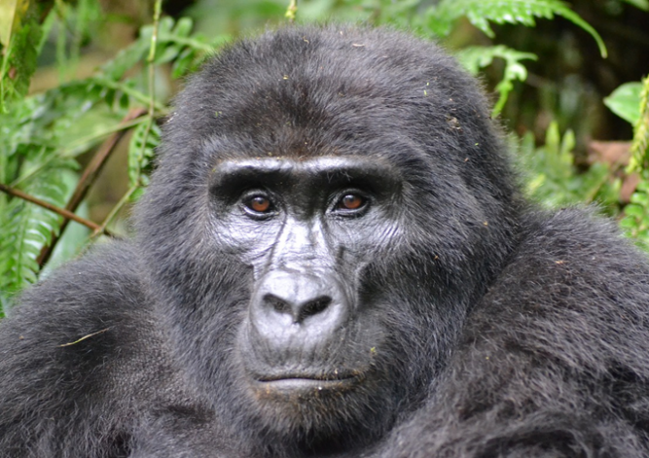
cloud forest
silverback
muscular
pounded
infant
slapped
playful
Word Wall
clambered
intimidating
mischievous

