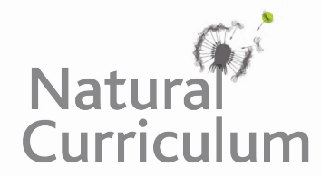
Learning Objective
We are learning how to use the first two or three letters of a word to check its meaning and spelling in a dictionary.

Challenge 1
Match the words with the correct definitions using a dictionary to support you.

submerge (vb) to feed on grass
semi-aquatic (n) an animal that eats only plants
tusk (adj) an animal (or plant) living partly on land and partly in water
herbivore (n) a long pointed tooth
graze (vb) to go below the surface of the water

Challenge 2
Put the following animals in alphabetical order. You may need to look at the second, third and fourth letter of each word.

hippopotamus hedgehog hornbill hyena hare hartebeest hummingbird humpback

Challenge 3
Create your own glossary using the words highlighted in the sentences below. Remember that a glossary is like a mini-dictionary for technical words found at the back of information books.

The large herd of semi-aquatic hippos were cooling themselves in the mighty Mara River. A dominant male was aggressively protecting his females from a rival male who had just wandered into his territory. His mouth was wide open, revealing several metre-long canines. Meanwhile a cow (female hippo) was guarding her young calf from a number of predatory crocodiles that were lurking, partially submerged in the river.

Here is an example of a glossary for some of the words that were on the Word Wall:

Glossary
digested – When food is broken down in the stomach into materials that the body can then use to provide energy.
herbivore - An animal that only eats plants.
mammal - Any animal of which the female feeds her young on milk from her own body.

