**Learning Objective**

We are learning how to use commas in lists.

**Challenge 1**

**Add the commas in the correct places in these sentences.**

1. Jaguars like to eat lots of different food including iguanas capybaras tortoises deer and fish.
2. Baby jaguars like to play by rolling around running stretching and chasing each other.
3. Many animals live in Brazil alongside jaguars including anteaters armadillos sloths monkeys and snakes.
4. When jaguars hunt, they find their prey stalk it quietly leap on it and then bite it with their super strong jaws.
5. Amazingly jaguars are quite the athletes and are able to swim well run fast and climb trees.

**Challenge 2**

**Add another action or item to the space in the sentence.**

1. Jaguars, ___________ and the ring-tailed monkey are all threatened by the destruction of the forests in Brazil.
2. Jaguars are powerful, secretive, ______ and strong creatures.
3. To help the jaguar cubs live in the wild, the team need to get closer to them, understand them, __________ and teach them how to survive.
4. When people see jaguars, they may think they are magical, magnificent, __________ and powerful.
5. Jaguars can live in various habitats such as forests, ___________ and deserts.

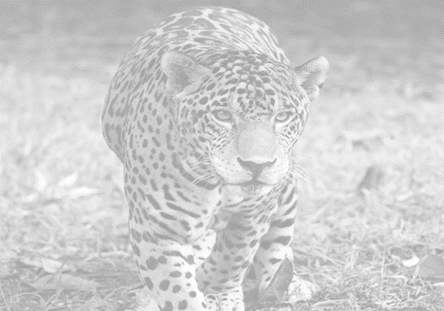

**Challenge 3  
Imagine that you have been on a wildlife holiday to the Amazon rainforest. On this incredible trip you saw many incredible animals such as hummingbirds, howler monkeys, toucans and poison dart frogs. Your highlight was getting a rare glimpse of the magnificent jaguar. Write about your trip using some of the descriptive words in the Word Wall and include at least two sentences that contain lists of items or actions.**

powerful

leapt

devoured

distinctive spots

seized

stealthily

jaguar

**Word Wall**

secretive