Learning Objective
We are learning how to use commas after fronted adverbials.

Challenge 1
Using link lines, match each fronted adverbial to the correct main clause.

In the fjords of northern Norway,
After stunning the fish with their tails,
Nervously,
Across a great distance,
As the orcas dived beneath the shoal,
Like a pack of wolves,

the orcas worked together.
the underwater cameraman entered the water.
the black and white giants were able to feast.
the orca whales were calling to each other.
the orca whales were gathering.
the herring became trapped against the surface of the sea.

Challenge 2
Rewrite the sentences below so that the adverbial phrase is at the front, separated from the rest of the sentence by a comma.

1) The black and white orca whales were gathering as the sun began to set.

______________________________________________________________________

2) The orca whale took a swipe at the shoal of fish without any warning.

______________________________________________________________________

3) The orca grabbed the unfortunate seal with its enormous toothed mouth wide open.

______________________________________________________________________

4) The impressive male orca made a strange clicking sound over and over again.

______________________________________________________________________

5) The orcas were hunting for something much larger close to the equator.

______________________________________________________________________

6) The orca gasped its last breath as it lay beached on the rocky shoreline.

______________________________________________________________________

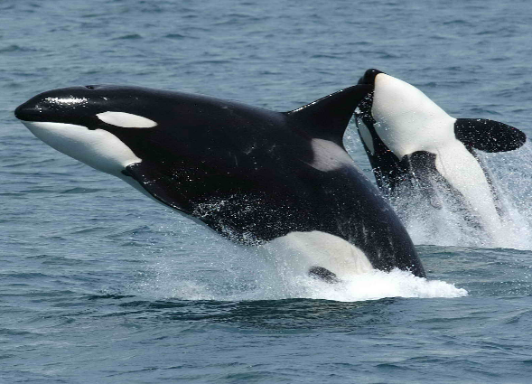
Challenge 3
Imagine that you were in the sea, filming the remarkable hunting technique of the orcas. Using some of the descriptive words from the Word Wall, write about your experience. Try to include at least 3 sentences that start with a fronted adverbial. (Remember – fronted adverbials give the reader information about when, how, where, how and how often an action took place.)
Word Wall
shoal
Orca whale
banquet
stunned
pod
herring
shockwave
herded
trapped

