**Learning Objective**

We are learning how to write effective expanded noun phrases.

**Challenge 1**

**Read the passage below. It has lots of simple noun phrases. Expand the simple noun phrases by adding an adjective from the list in the spaces provided.**

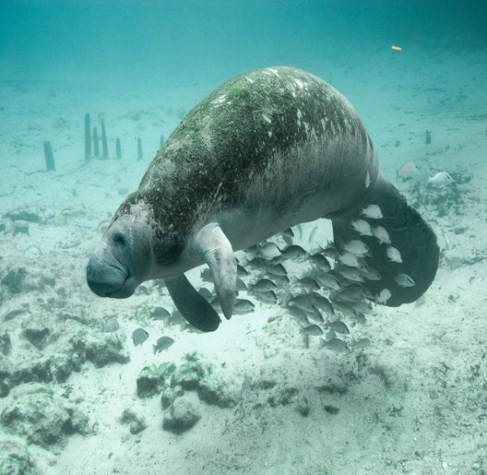

All of sudden, I heard a deep exhale of breath. I turned around and right behind my kayak was a manatee. I could see its ___________ tail moving up and down just beneath the surface of the _________ water. Sadly, it had a badly _________ body, which must have been caused by the __________ propeller blades of a motorboat. In the __________ water I was able to see how it used its _________ upper lip to rip up grass that was growing from the riverbed. I was so thrilled to be sharing this part of the river with this ________ giant. My trip to Florida, which is nicknamed the ________ State, will be etched into my memory forever.

**Adjective   
List**

knife-like

gentle

scarred

sunshine

powerful

crystal-clear

shallow

paddle-shaped

**Challenge 2**

**Use an adjective (before the underlined noun) and a prepositional phrases (after the underlined noun) to make each simple noun phrase in the sentences below more descriptive. Start your prepositional phrases with one of the following prepositions:**

**with**

**on**

**at**

**in**

1)In the narrow river channel, the manatees faced daily danger.

**e.g. In the narrow river channel, the roly-poly manatees with inquisitive natures face daily danger.**

2) Near the hot springs, the manatees were gliding through the shallow water.

3) As the river narrowed, the motorboatcollided with the slow-moving manatee.

4) The tourist was getting ready to film the aggregation of manatees.

5) The snorkeller could see the manatees feeding on the floating vegetation.

**Challenge 3**

**Imagine that you were one of the snorkelers that we saw in the film clip. Despite not being allowed to touch the manatees, a young inquisitive calf decided to take a liking to you and, using her flippers, pulls you in towards her for a cuddle! (This writing idea has been taken from a real-life encounter!) Write about this remarkable encounter using lots of effective expanded noun phrases that use both adjectives and prepositional phrases to build description.**