Learning Objective
We are learning how to write effective expanded noun phrases.

Challenge 1
Read the passage below. It has lots of simple noun phrases. Expand the simple noun phrases by adding an adjective from the list in the spaces provided.
The view from the top was magnificent. ________ mountains stretched for as far as I could see. The __________ mountain that I was about to ski down was the tallest in this range.
Three, two, one … I was off! Within seconds, I had accelerated to a great speed. Incredibly, it wasn’t long before the ______________ falcon had overtaken me. There was nothing I could do to catch up with this _____________ bird of prey.
When I finally came to rest at the foot of the _____________ mountain, I looked up and saw the peregrine soaring high above. Its _____________ breast was clearly visible in the _____________ sky.

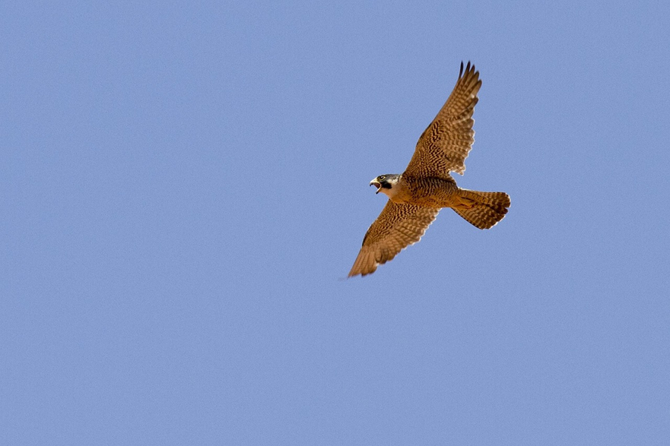
.
Adjective
List

teardrop-shaped

towering
banded

cloudless
flour-white

lightning-fast
rugged

Challenge 2
Use an adjective (before the underlined noun) and a prepositional phrases (after the underlined noun) to make each simple noun phrase in the sentences below more descriptive. Start your prepositional phrases with one of the following prepositions:
on

with
in
at

1) The chicks were waiting for their mother to return.
e.g.The ravenous chicks with beaks wide open were waiting for their mother to return.
2) The majestic falcon carried the pigeon to its nest on the cliff ledge.
3) The mountain range was the perfect setting for the remarkable race.
4) The skier was getting ready to race the peregrine falcon.
5) It was time for the chick to leave the nest.

Challenge 3
Imagine that you have been asked to provide a sports commentary on the race between the Olympic skier and the peregrine falcon. Write down your commentary using lots of descriptive expanded noun phrases. Try to include some prepositional phrases within your expanded noun phrases. You could start your writing with the following two sentences.

“It’s a glorious day with not a cloud in the sky. The two eager contestants at the top of this towering mountain are raring to go.”

