Learning Objective
We are learning how to start sentences in a variety of interesting ways.

Challenge 1
Using link lines, match each sentence starter to the correct sentence ending

Repeatedly,
Searching amongst the sand,

Clasping the clam with its oversized teeth,
As quick as a flash,
Determined,
the tusk fish swallowed the fleshy part of the clam.
the tusk fish smashed the shell against the coral twenty times.

the tusk fish smashed the clam against the hard coral.
the tusk fish carried the clam.
the tusk fish found the hidden clam.

Challenge 2
Finish the sentences in a way that is as interesting as they start.

- Suddenly, the tusk fish moved …
- Pleased, the tusk fish ….
- Looking all around the sea bed, ……
- Amazingly, the tusk fish used its mouth to ….
- Lifting items from the sea bed, …
- Cracking the shell open, …

Challenge 3
Write a short description of the amazing tusk fish and how it cleverly manages to both find the elusive clams and then crack them open on the coral using only its mouth. Try also to use some of the descriptive words from the Word Wall.

muscular

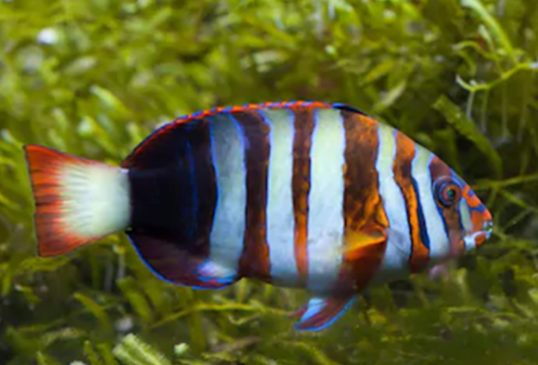
Interesting sentence starter reminder:
- Start with an ‘ed’ or ‘ing’ ending
verb
- Start with a ‘ly’ ending verb
- Start with a simile

Word Wall
clasped
tusk fish

snaggle-toothed
repeatedly
fleshy
coral
determined
collected
clam
resilient
shattered

