Learning Objective
We are learning how to write sentences in both the simple past tense and its present perfect form.

Challenge 1
Complete the following simple past tense sentences with the correct verb from the list below.
devoured
built
constructed
discovered
backed
squirted
scurried

- The colossal ant nest was ____________ on an old tree stump.
- The ants _____________ their nest from pine needles.
- The ants ____________ around their nest looking for building materials.
- The domed nests were ______________ on the forest floor amongst the pine trees.
- The wood ants _________________ miniature fountains of acid at their enemy’s face.
- The cow ____________ away as the unpleasant spray entered her nostrils.
- The hungry wood ants ______________ the large beetle in a matter of minutes.

Challenge 2
Rewrite the following sentences in the past tense using the present perfect form. Remember - in the present perfect, a sentence must include the word ‘has’ or ‘have’ and the main verb (bold) must end in –ed (unless it is an irregular verb).

- The super strong ants are dragging the enormous caterpillar back to their nest.

e.g. The super strong ants have dragged the enormous caterpillar back to their nest.

- Sir David Attenborough is looking for the termite mound.
- The ants are beginning their lives as an egg.
- The queen wood ant may live for 10 – 15 years.
- The queen is living deep inside the nest.
- The wood ants are collecting honeydew from the aphids.
- The wood ants are defending their nest from the clumsy hoofed herbivores.

Now use your editing skills to add an additional word to each sentence to make it more descriptive.
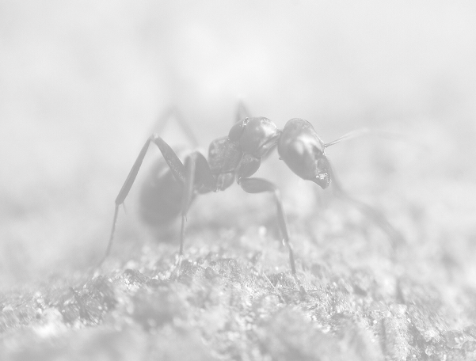
Challenge 3
Using some of the descriptive words from the Word Wall, see if you can write your own sentences about wood ants (or ants in general). Try to include a mixture of sentences that are in the simple past tense and its present perfect form.
Word Wall
colony
wood ants
acid
sprayed
pine needles
defended
nest
aggressively
destroyed
dragged
constructed
foraged

