Learning Objective
We are learning how to write effective expanded noun phrases.

Challenge 1
Read the sentences below. Add two adjectives before each noun to create an expanded noun phrase.

- These ________ ___________ animals are able to adapt to _________ and _________ circumstances.
- The Arctic fox has _______ _______ fur and ________ ________ ears to enable it to survive the ___________ __________ temperatures.
- Their cousins, the ________ _________ red fox, can be twice the size of the Arctic fox.
- In __________ ____________ towns, Arctic foxes can be found scavenging for food.
- Arctic foxes will eat ________ _________ food to ensure their survival.

Challenge 2
Use an adjective (before the underlined noun) and a prepositional phrase (after the underlined noun) to make each simple noun phrase in the sentences below more descriptive. Start your prepositional phrases with one of the following prepositions:
with
at
in
on

1) Arctic foxes build dens.
e.g. Arctic foxes build underground dens with long complex tunnels.
2) The Arctic fox explored the town looking for food.
3) After hours of looking, the Arctic fox finally enjoyed a meal.
4) Diving high, the Arctic fox pounces on some lemmings.
5) In winter, Arctic foxes struggle to find food so will eat anything they can.

Challenge 3
Imagine you are a BBC camera person watching the Arctic fox as it explores its frozen environment looking for food. Write a description of what it looks like and how it moves using expanded noun phrases to give the reader that extra detail. Try to include some of the words that are on the Word Wall. You could use the following sentence to get off the starting block:
Moving gracefully across the snow, the almost-invisible Arctic fox with its round furry body, is on the hunt for food.
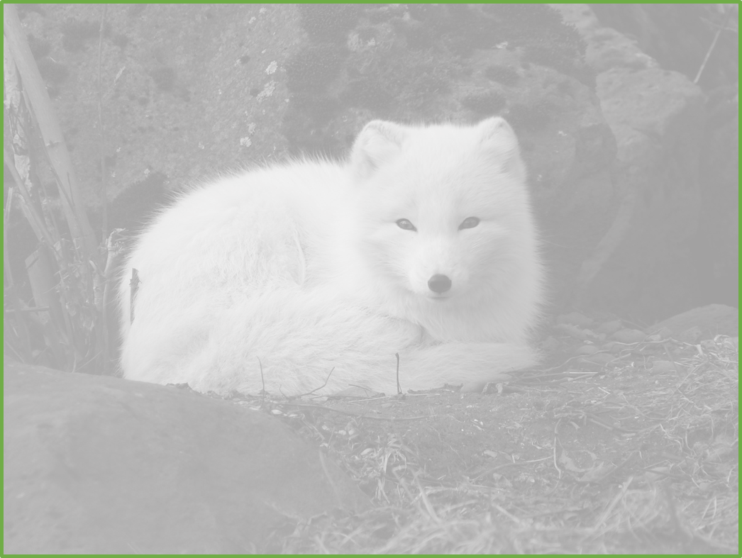
Word Wall

Arctic fox
survival
sub-zero
red fox
adapted
Alaska
intrepid
pounced
wilderness
scraps
lured
howling wind
blizzard

