Learning Objective
We are learning how to use commas after fronted adverbials

Challenge 1
Using link lines, match each fronted adverbial to the correct main clause.

On land,
Having just dived into the Tasmanian lake,

In the depths of the murky lake,

When needing to find food,

When a platypus is under water,
Screaming in agony,
the unusual-looking mammal was completely blind.
the platypus uses its bill to detect the electrical signals that are given off by other animals.
the platypus walked in an awkward fashion.
the reasons for its hodgepodge of body parts become clear.
it was clear that the lady had just been
stung by a male duck-billed platypus.
the platypus used its webbed feet to reach the bottom.

Challenge 2
Rewrite the sentences below so that the adverbial phrase is at the front, separated from the rest of the sentence by a comma.

1) The platypus’ leathery eggs hatched after ten days.
__________________________________________________________________________

2) His otter-like fur kept him warm in the cold lake.

__________________________________________________________________________

3) It can be difficult to avoid rocks on the lake bed.

__________________________________________________________________________

4) Due to the platypus’ unique build, it swims through the water effortlessly.

__________________________________________________________________________

5) The hungry platypus searched for food with great determination.

__________________________________________________________________________

6) The male is venomous so it can unleash a toxic sting when an enemy attacks.

__________________________________________________________________________
Challenge 3
You were exploring Tasmania, when you saw a platypus waddling along the ground. Quickly, you put on your diving gear and followed it into the water. Write about this experience using some of the descriptive words from the Word Wall. Try to include at least 3 sentences that start with a fronted adverbial. (Remember – fronted adverbials give the reader information about when, how, where and how often an action took place.)
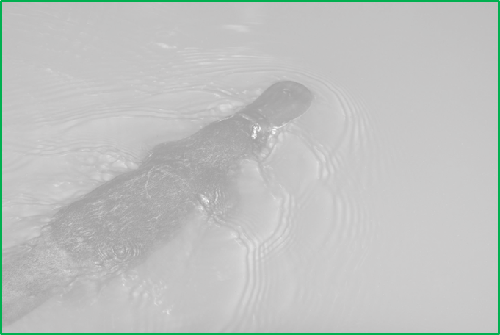
9
Word Wall
water
clever
manoeuvre
hodgepodge
navigated
lake
calm
bumped
duck-billed
graceful
dived
fearlessly

