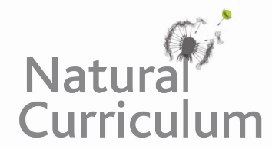
Learning Objective
We are learning how to use the first two or three letters of a word to check its meaning and spelling in a dictionary.

Challenge 1
Match the words with the correct definitions using a dictionary to support you.

carrion (vb) moving with short quick steps

burrow (n) an animal that eats plants and meat

migrate (n) a dead decaying animal

omnivore (vb) to move from one habitat to another

scuttle (n) a home made by an animal which has been dug underground

Challenge 2
Put the following animals in alphabetical order. You may need to look at the second, third and fourth letter of each word.
cassowary
cayman
cat
camel
capybara
caterpillar
crab

Challenge 3
Create your own glossary using the words highlighted in the sentences below. Remember that a glossary is like a mini-dictionary for technical words found at the back of information books.

Crabs are decapods and come in a wide variety of shapes and sizes. The coconut crab is one of the world’s largest crabs with an omnivorous diet. Using their pincers, they take their food to their burrows where they eat it in seclusion. Their diet includes such things as carrion, old fruit and even the shells of other crabs so that they can ingest the calcium contained within them. Their life cycle begins with the female laying eggs which are in a larval form. This larva feeds on small organisms for about 20-30 days before it leaves the water to live on land.

Here is an example of a glossary for some of the words that were on the Word Wall:
Glossary
kleptomaniac – someone or something which has a recurring urge to steal.
robber – someone or something which takes an item that doesn’t belong to them.
coconut – the large brown seed of a tropical palm tree.

