**Learning Objective**

We are learning how to write sentences in both the simple past tense and its present perfect form.

**Challenge 1**

**Complete the following simple past tense sentences by adding the appropriate verb from the list below:**

**surrounded**

**lived**

**watched**

**recognised**

**waited**

**flew**

1. The baby albatross ______________ as other parents returned to their offspring.
2. Wisdom ___________ back to feed her baby after being away for two long weeks.
3. The baby instantly _____________ his mum.
4. Due to her age, Wisdom was ___________ by three generations of her family.
5. The baby _________ two weeks for his mother to return.
6. Hundreds of other albatrosses _____________ on the island with them.

**Challenge 2**

**Rewrite the following sentences in the past tense using the present perfect form. Remember - in the present perfect, a sentence must include the word ‘has’ or ‘have’ and the main verb (bold) must end in –ed (unless it is an irregular verb).**

1. The mother albatross is **racing** home to see her baby.

**e.g. The anxious mother albatross has raced home to see her baby.**

1. Worryingly, the baby albatross is **waiting** for too long to be fed.
2. Both mother and father are **taking** it in turns to look after the single egg.
3. Albatrosses have been **living** on this island for hundreds of years.
4. Wisdom, who is the oldest known bird, is **hatching** her 37th chick.
5. After 5 long years at sea, Wisdom’s son will **return** to land.
6. The mother albatrosses **search** for food to take back to their babies.

**Now use your editing skills to add an additional word to each sentence to make it more descriptive.**

**Challenge 3   
Using some of the descriptive words from the Word Wall, see if you can write your own sentences about the experience of the baby albatrosses – flightless and dependent on waiting for their mothers to return with food. Try to include a mixture of sentences that are in the simple past tense and its present perfect form.**

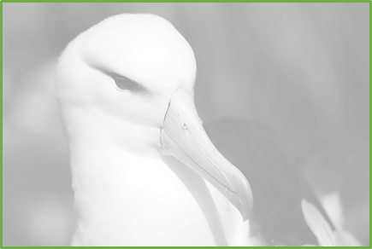

albatrossy

searing tropical sun

chicky

wingspan

dependent

patiently

flightless

appeared

surrounded

ravenous