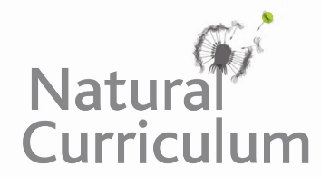
Learning Objective
We are learning how to organise paragraphs around a theme.

Challenge 1
Under the title The Nile Crocodile, cut out and organise the sentences below into four clear paragraphs before sticking them into your book. The Topic sentences are highlighted bold.

Challenge 2
Before you stick the sentences into your book, give each paragraph a subheading.

Challenge 3
Once you have completed challenges 1 and 2, write your own concluding paragraph.

Sixty years ago in Egypt, Nile crocodiles were hunted to near extinction.
As Nile crocodiles get bigger, the animals they eat also increase in size.
Crocodiles are formidable hunters.
On average, these crocodiles are between 3.5 and 5 metres in length.
The main threats come from humans and include river pollution, hunting and habitat loss.
They launch ambush attacks when prey animals approach water to drink.
Young crocodiles eat insects, small fish and frogs.
The attack is sudden with the crocodile lunging its body out of the water and grabbing its victim.
Nile crocodiles are the largest of the African crocodilians.
Despite being at the top of the food chain, Nile crocodiles face a number of threats.
An adult crocodile can catch and eat an animal as large as a zebra, an antelope or even a buffalo.
However, some monster specimens have measured over 6 metres in length and weighed over 1,000 kilograms!

