Learning Objective
We can use modal verbs and adverbs to indicate degrees of possibility

Challenge 1
Order the following modal verbs and adverbs from least possible to most possible:
probably
will
might
couldn’t
rarely
certainly
perhaps

Can you add other modal verbs or adverbs to this list?

Challenge 2
Using a combination of modal verbs and adverbs, complete the following sentences. The likelihood of each event/action taking place is indicated by the word (inside the brackets) at the end of the sentence

I ................ be able to look after the baby better than you. (certain)
The larger female will .................. win the fight. (certain)
The grandmother elephant ................... let the elephant take the baby away. (Not very certain)
............................. the mother will come back and get her baby. (Not very certain)
If I were the baby, I .................... run away and find my mum. (Fairly certain)
Challenge 3
Write a short newspaper article for the Sri Lankan Times that details the highly unusual elephant theft featured in the main clip.
Try to include in your article some modal verbs, modal adverbs and descriptive words from the Word Wall.
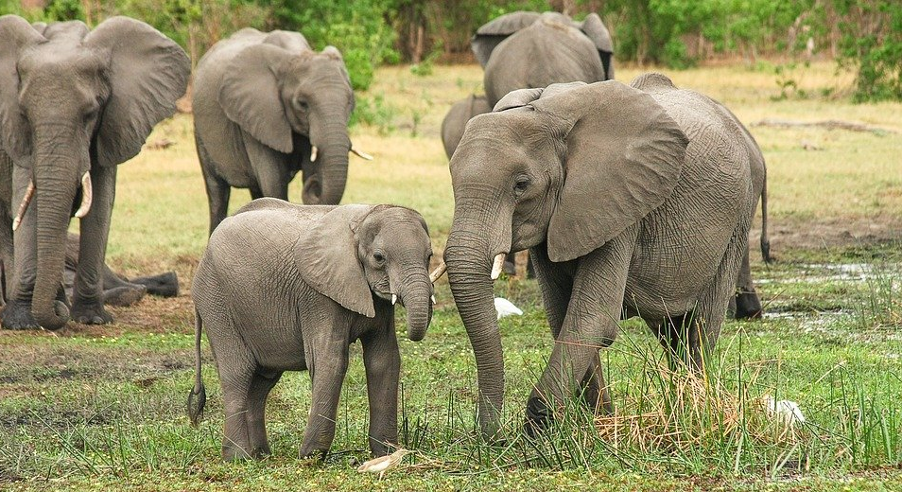
Word Wall

can
usually
must
will
might
could
perhaps
certainly
probably
often
shall

jostled
conflict
bewildering
Asian elephant

defeated
bulldozed
dominant
trumpeted

Stretch activity
Write a set of rules to tell the female elephants how they should behave in their herd and live in harmony together. Use the most appropriate modal verbs and adverbs to get your message across in the strongest terms to make sure all elephants obey!

Helpful Hint:
Make a list of the modal verbs and adverbs that are the most certain (this can include negatives e.g. won’t or will not).
Think of about 5 rules for the elephants to follow. (e.g. All elephants MUST wash behind their ears every day.)
Present them in a poster or rule book.

