Learning Objective
We are learning how to use relative clauses beginning with who, which, where, when, whose, that or with an implied (i.e. omitted) relative pronoun.

Challenge 1
Read the passage below and highlight all of the relative clauses.

During monsoon season, which sees over 3 metres of rain fall, the male brown banana frog makes it his mission to find a mate during breeding season. As the stormy skies rage on, the male frog leaps from bamboo branch to branch, making sure to reach that perfect spot to find his mate – who isn’t going to be around for long. The banana frog (whose petite body is no larger than a bottle top) makes the mammoth climb to reach the tops of the dripping branches, and with eyes peeled he soon spots he isn’t the only male banana frog there. All sitting perched on the branches, the male banana frogs, who extend their throats to ‘sing’ to the female, must be higher on the branches for their croaks to be heard. The highest spots to perch on are much sought after and therefore always fought over by the other males, where many find themselves clinging on to stay in the breeding race, using their long, extending legs to knock opposing males off their branches. For the triumphant male Banana Frog, will their mate be waiting for them at the top?

Challenge 2
Rewrite the following sentences, adding a relative clause to each one. Try to use a range of relative pronouns, and don’t forget to punctuate your sentences accurately!

- Within the rainforest _________________ the banana frog was looking for a male.

- The determined Banana frog ________________ jumps enthusiastically through the dripping bamboo branches.

- The female Banana frog __________________________ will only be able to hear the loudest croak; therefore, the male frogs know they need to be at the very top of the canopy______________________ .
Challenge 3
Using the Word Wall below, write a description of a male Banana frog and his fight to be found by a potential mate on those drenched branches. Include several relative clauses, each time using a different relative pronoun, written or implied (omitted).
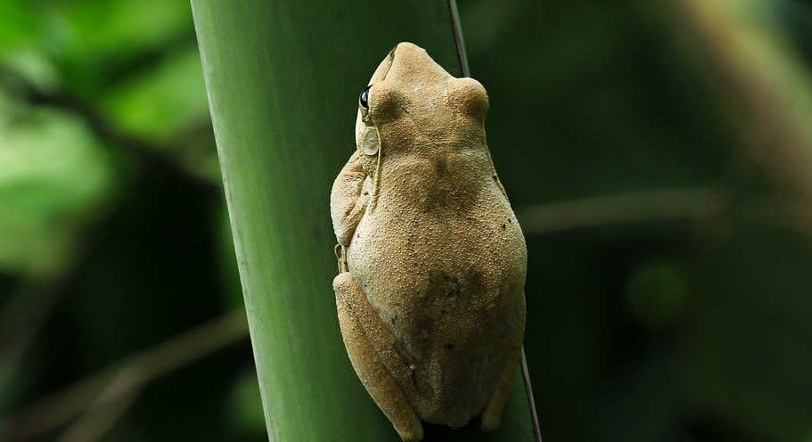
Word Wall

drenched
rival
amphibian
banana frog
croaked
monsoon rain
determined
leapt
competitive
cacophony
booted
struck
eagle-eyed
deluge
bamboo forest
triumphant
poetic love-dance

