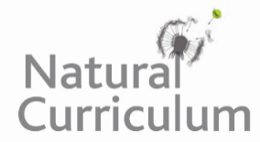
Learning Objective
We are learning how to use the first three or four letters of a word to check its meaning and spelling in a dictionary.

Challenge 1
Match the words with the correct definitions using a dictionary to support you.

domestic (adj) thinly scattered
sturdy (verb) eat grass in a field
tusk (adj) strongly or solidly built
sparse (n) a long pointed tooth
graze (adj) relating to home or to family relations.

Challenge 2
Put the following animals in alphabetical order. You may need to look at the second, third and fourth letter of each word.
whale
walrus
weasel
worm
wildebeest
wombat
wallaby
warthog

Challenge 3’run
Create your own glossary using the words highlighted in the sentences below. Remember that a glossary is like a mini-dictionary for technical words found at the back of information books.

A tentative mother warthog was hesitant to take her piglets out of their protective den for the first time. Still, she knew it was crucial that they develop their survival skills, especially avoiding predators. Exploring the savannah, the youngsters boldly played together, running around at speeds they’d never run before. Having exhausted themselves from so much fun, the family sought respite from the sweltering heat, finding a shallow pool of water. However, unbeknownst to the warthogs, a fearsome cheetah lurked in the trees, observing its prey…

Here is an example of a glossary for some of the words that were on the Word Wall:
Glossary
obliged – feeling bound to someone to do something for them.
beneficial – something that is advantageous to someone.
embraced - accepting something willingly or enthusiastically.

