
Learning Objective
We are learning how to use figurative language.

Challenge 1
Copy and complete the following sentences. Will you make them the same as the sentences that were modelled in the lesson, or will you make them different? The figurative device that you need to use is indicated inside the brackets.

(personification) As the wasp uncovered the spider, she _____________ her hands together, ____________ with delight.
(metaphor) The wasp and the spider were __________ , entwined in a ________________ .
(simile) The spider rolled down the sand dune like _________________________________ .

Challenge 2
Using your knowledge of the golden wheel spider, the pompilid wasp and their desert habitat, copy and complete the following sentence openers using the figurative language device indicated inside the brackets.

(simile) The golden wheel spider span ______________________________________ .
(metaphor) The pompilid wasp was a _______________________________________ .
(personification) As the blistering sun ______________________________________ .
(simile) The golden wheel spider burrowed ____________________________________ .
(metaphor) The desert was a _____________________________________________ .
(personification) Like a scene from a horror movie, she ___________________________ .
(simile) The shifting desert was like _________________________________________ .
(metaphor) As the desert furnace became unbearable, the _________________________ .

Stretch activity: For each sentence above, give some additional information/detail about each underlined noun by including a parenthesis or a relative clause.

Challenge 3
Imagine you are the pompilid wasp from the video. You are frustrated that after all your hard work, the golden wheel spider got away! Write a diary entry about your day, using a range of figurative devices such as metaphor, simile and personification. Try to use some of the descriptive words from the Word Wall.

Word Wall
Word Wall
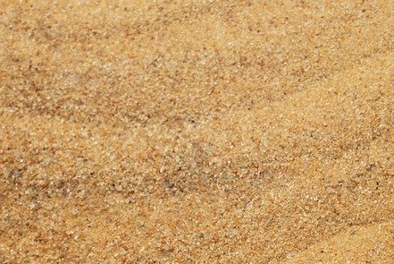
Word Wall
Word Wall
pompilid wasp
golden-wheel spider
Namib Desert
arachnid
sand dune
trundle wheel
skittered
shovelled
paralysed
inserted
grizzly
carousel
rotating

