Learning Objective
We are learning how to use the passive voice to affect the presentation of information within a sentence.

Challenge 1
Decide if the following sentences are in the active or passive voice.
- Grey squirrels largely replaced the native UK red squirrel. (active/passive)
- The red squirrel population has been reduced by the presence of (active/passive)
grey squirrels.
- Cold weather forces grey squirrels to be less active in the winter. (active/passive)
- Grey squirrels destroy native woodland. (active/passive)
- Landowners released grey squirrels in the UK in the 1800s. (active/passive)
- The nuts were stashed in a safe place by the wily squirrel. (active/passive)

Challenge 2
Rewrite the following active voice sentences in the passive voice so that the agent of the action (bold) moves to the end of the sentence and the object (underlined) moves to the front (and becomes the subject of the sentence).
- Grey squirrels pester many bird owners by eating the bird food from their gardens.
e.g. Many bird owners are pestered by grey squirrels that eat the bird food from their gardens.
- The squirrels eat food such as nuts, acorns and berries.
- Nature lovers often spot grey squirrels in woodland areas.
- Foresters dislike grey squirrels because they damage trees.
- The cunning squirrel fooled the nut thief many times.

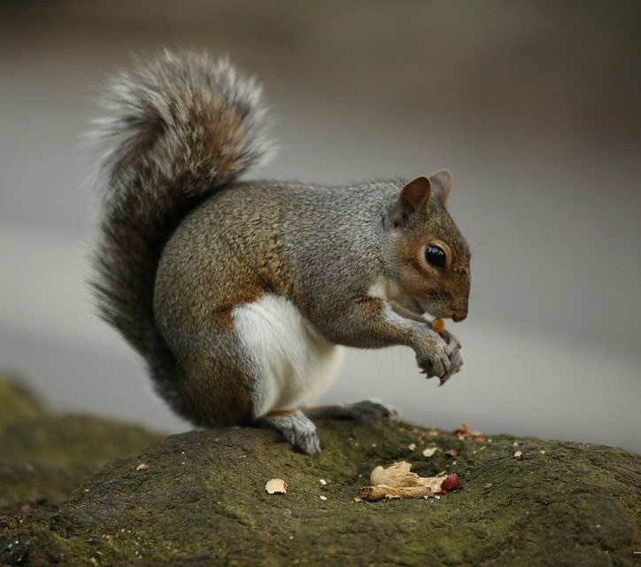
Challenge 3
stashed
deceived
acorn
foolishness
thief
trickster
squirrelled away
sleight of hand
underground larder
grey squirrel
Word Wall
Write a paragraph describing a mischievous grey squirrel, like the one in the clip. Try to follow this writing structure:
Sentence 1: Your sentence must be in the active voice.
Sentence 2: Your sentence must include a simile.
Sentence 3: Your sentence must be written in the passive voice.
Sentence 4: Your sentence must include a relative clause.
Sentence 5: Your sentence must include at least 2 words from the Word Wall.

