Learning Objective
We are learning how to use the passive voice to affect the presentation of information within a sentence.

Challenge 1
Decide if the following sentences are in the active or passive voice.
- The hippopotamus was named for its love of water by the Greeks. (active/passive)
- Mother hippos give birth to one calf every two years. (active/passive)
- The hot, African sun beats down upon the hippos. (active/passive)
- Hippos are protected from the sun by an oily substance they secrete. (active/passive)
- The raging hippo charged at the safari jeep that was filled with (active/passive)
nervous tourists.

Challenge 2
Rewrite the following active voice sentences in the passive voice so that the agent of the action (bold) moves to the end of the sentence and the object (underlined) moves to the front (and becomes the subject of the sentence).
- Disease and drought threaten hippos in the African wilderness.
e.g. Hippos are threatened in the African wilderness by disease and drought.
- Predators lurking around make young hippos vulnerable.
- A dominant male leads a group of hippos.
- Poachers have caused the number of hippos in the wild to decrease.
- The bush pigs scarred the young hippo with their tusks.

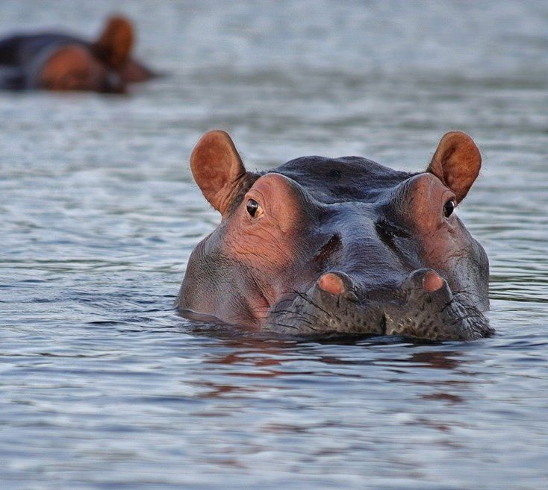
Challenge 3
Write a paragraph describing a pair of hippos, either in a sanctuary like Emma and Molly, or in the wild. Try to follow this writing structure:
Sentence 1: Your sentence must be in the active voice.
Sentence 2: Your sentence must include a simile.
Sentence 3: Your sentence must be written in the passive voice.
Sentence 4: Your sentence must include a relative clause.
Sentence 5: Your sentence must include at least 2 words from the Word Wall.

Word Wall
defenceless
soothing moisturiser
bond
inseparable
wallowed
rubbed
vegetable smoothie
emerged
slurped
rescued
attacked
scars
fearsome
vulnerable
sanctuary
surrogate mum
rehabilitation
orphaned
hippopotamus

