Learning Objective
We are learning how to use hyphens to avoid ambiguity with word meanings.

Challenge 1
Complete the sentences below with the most suitable hyphenated words from the following list:
nimble-footed
human-like
pitch-black
re-entered
runner-up

mischievous-looking
high-rise
warm-blooded
two-year-old

- The ______________ raccoon disappeared without a trace into the alleyway.
- Despite the danger, the masked raccoon _______________the garbage bin.
- The ______________ raccoon was already two thirds of the way through its short life.
- In contrast to cold-blooded creatures, ______________ raccoons have a stable body temperature of around 101 – 103 degrees Fahrenheit.
- The occupants of the ____________building should avoid leaving uneaten food items in their wheelie bins.
- In the ____________ , a ____________raccoon was thumbing a piece of chicken in its _______________ hands.
- Once more, the unlucky raccoon was the ___________ in the race to find a tasty scrap of human food.

Challenge 2
Correct the sentences below by joining the words that require a hyphen between them.

- The wildlife presenter re discovered his love for the mischeivious looking raccoons after spending some time observing them in the wild.
- The quick witted raccoon waited for the traffic lights to change before re crossing the busy road.
- The abandoned raccoon kit was hand raised in an animal sanctuary before being released into the wild.
- Thirty six raccoons were spotted in the vicinity of the newly built three storey block of flats.
- The award winning wildlife photographer snapped the raccoon as it tiptoed its way across a high voltage telephone wire.
Challenge 3
Write your own narration for the main clip in the style of David Attenborough. It should include some figurative language, factual information about raccoons, elements of suspense and a generous handful of hyphenated words. You may find some of the words in the Word Wall helpful when completing this writing challenge.
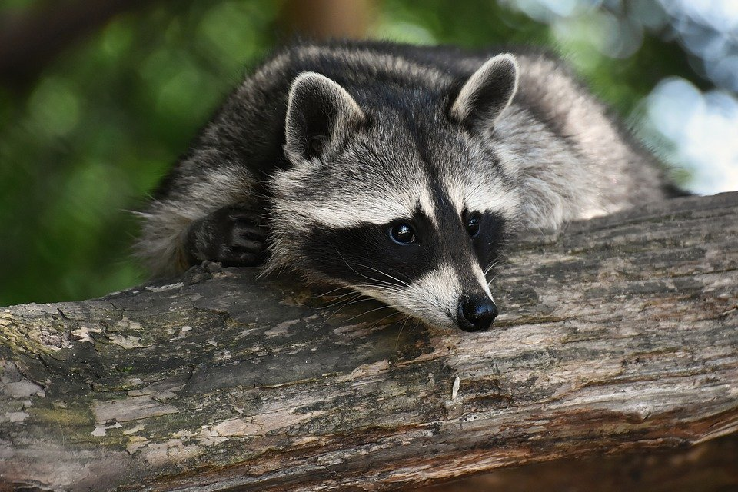
high-voltage
nocturnal
quick-thinking
deep-fried
nimble-footed
high-rise
well-known
one-way
masked bandit
agile
re-entered
urban
raccoon
Word Wall

