
Learning Objective
We are learning how to use figurative language.

Challenge 1
Copy and complete the following sentences. Will you make them the same as the sentences that were modelled in the lesson, or will you make them different? For each sentence, the figurative device that you need to consider is indicated inside the brackets

(simile) As the springbok grazed, the butterflies flew like _________________________ .
(personification) The ancient baobab trees ___________________ the springbok pronked around their gnarled and twisted ___________________ .
(metaphor) The young springbok was_________________, elegantly prancing around his ____________________________ .

Challenge 2
Using your knowledge of the springbok featured in the film clip and their grassland playground, copy and complete the following sentence openers using the figurative language device indicated inside the brackets.

(simile) The young springbok was as energetic ___________________________________ .
(metaphor) Watching over her youngster, the ___________________________________ .
(personification) Casting their shadow over the grassland, the clouds _________________ .
(simile) From a distance, the dark patches around the springbok’s eyes ________________ .
(metaphor) Gleefully, the __________________________________________________ .
(personification) As the pronking commenced, the springbok ________________________ .
(simile) The grass sprouted like _____________________________________________ .
(metaphor) The rams (male springbok) jumped around their _________________________ .

Stretch activity: For each sentence above, give some additional information/detail about each underlined noun by including a parenthesis or a relative clause.

Challenge 3
Imagine you are a commentator at the African Animalympics. You are providing the commentary for the springbok high jump. Describe the magnificent movements of these animals using a range of figurative devices such as metaphor, simile and personification. Try to include some of the descriptive words from the Word Wall.
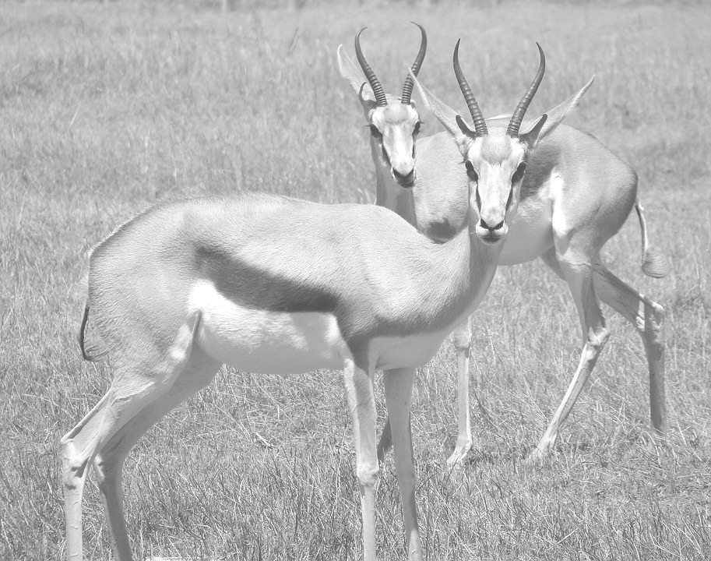
Word Wall
springbok
adaptable
gleefully
savannah
motion
high-octane
pronking
frolicked
sprouting
celebrating
ballerina
grazing

