Learning Objective
We are learning how to use bullet points consistently.
Bullet points are used to help the reader locate information quickly and precisely, especially when there is a lot of complicated information to be understood. Most commonly they break down information into lists of items or key points.

Challenge 1
Think back to the generally agreed conventions for using bullet points. With a talk partner, see if you can identify the mistakes that have been made for each of the bulleted lists below and use your editing skills to make any necessary corrections.

1)  The diet of a Sumatran rhino includes the following foods  - Mangoes  - Figs  - Bamboo  - Cultivated crops | 2)  The diminutive Sumatran rhino has the following body size dimensions:  - it is between 1 and 1.5 metres tall  - It is about 2.5 metres long.  - it weighs between 500 and 960 kilograms  - Its larger front horn is typically 15 – 25 centimetres long.
3)  In the wild, Sumatran rhinos face a number of threats  Farming is destroying their natural habitat.  they are killed for their horns  Small and isolated populations make breeding very difficult | 4)  Here are some things that you could do to help save the Sumatran rhino population from extinction:
Challenge 2
Using your newly-acquired knowledge of the Sumatran rhino, write a short information report about this remarkable species that uses a range of presentational devices such as headings, sub-headings, bullet points, fact boxes and tables. See if you can include some of the words from the Word Wall in your report.
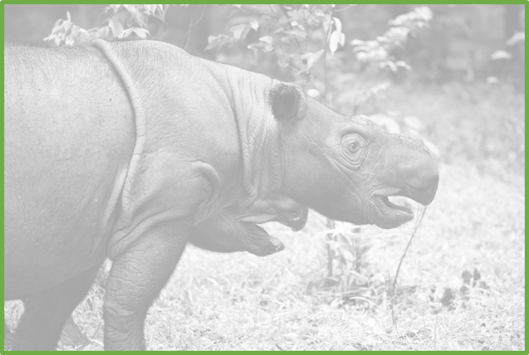
Word Wall

Sumatran rhino
roam
Indonesia
poachers
breed
sanctuary
extinction
solitary
captive
protected area area
deforestation

