Learning Objective
We are learning how to use bullet points consistently.
Bullet points are used to help the reader locate information quickly and precisely, especially when there is a lot of complicated information to be understood. Most commonly they break down information into lists of items or key points.

Challenge 1
Think back to the rules for using bullet points. With a talk partner, see if you can identify the mistakes that have been made for each of the bulleted lists below. Use your editing skills to make any necessary corrections.

1. The Tasmanian devil makes its home in various places, including  - under stones  - in hollow logs  - in caves and bushes | 2. The Tasmanian devil is related to many other unusual animals:  the quoll  the numbat  the fat-tailed dunnart  the wambenger | 3. There are many interesting facts about the Tasmanian devil  - They are the top carnivores in Tasmania  - they travel long distances each night in search of food.  - their young are called imps

Challenge 2
Rewrite each of the following fact boxes using bullet points. Remember to be consistent and to use the correct sentence punctuation.

1. Their habitat includes eucalyptus forests, woodlands, coastal scrubland and agricultural areas. | 2. When threatened, a devil will lunge at its attacker, shriek, howl, bare its teeth and often spin around in circles. | 3. In captivity, Tasmanian devils are fed a diet of rabbit, mice, rats, fish and cow bones.

Challenge 3
Using your newly-acquired knowledge of the Tasmanian devil, write a short information report about this remarkable species. Use a range of presentational devices to organise your writing, including headings, sub-headings, bullet points, fact boxes and tables. See if you can include some of the words and phrases from the Word Wall in your report.

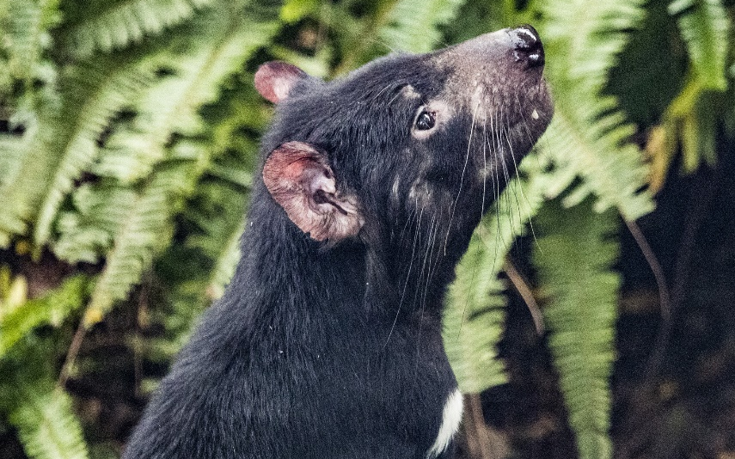
Tasmanian devil
logs, caves, burrows
Tasmania
marsupial
voracious eaters
coarse fur
carrion
scavenger
imps
nocturnal
mammal
carnivore
Word Wall

