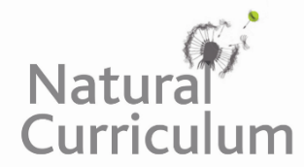
Learning Objective
We are learning how to proofread for spelling and punctuation errors

Challenge 1
Look carefully at the punctuation use at the beginning and end of each of these sentences. Punctuate the following sentences correctly.

- the genus name for the six-plumed bird of paradise is Parotia and there are five other species in the same group
- Did you know that the male bird does not help raise the young
- what an amazing dancer he is
- the males certainly work hard to attract a female, don’t they
- Scientists aren’t too sure how many eggs a female lays at a time, but they think it is between one and three
- how bright his iridescent neck collar is

Challenge 2
The following sentences have been edited for spelling, capital letters and full stops, so why don’t they make sense? Re-write the sentences so that they are clear, they make sense and they still have correct spelling and punctuation.

- The male bird of paradise do ballet-like moves to impressing the females. (2 mistakes)
- Before he can perform the male makes sure stage is spotless. (2 mistakes)
- He hop and he jump about to make his eyebrow plumes dance in air. (3 mistakes)
- As he spots a female he ruffles out his skirt feathers and bops head. (2 mistakes)
- The dense rainforest are home to the six-plumed bird of paradise. (1 mistake)

Challenge 3
Read the paragraph below very carefully. There are 10 missing pieces of punctuation (including full stops, capital letters, exclamation mark, brackets and commas). There are also 10 spelling mistakes.

the six-plumed bird of paradise is native to the forsets of New guinea As their habitat is in a remote place not much is nown about these birds. The male is quiet striking with six long ornate eyebrows with black oval tips. He also has bright Blue eyes a reflective neck collar (which shimers when he dances and a band of feathers that he can rufle out to look like a skirt. Wat hard work it is to attract a female before he can start his dance routine which involves him hoping and boping about showing of his feathers he cleans his stage by removing any debris and wiping viewing perches with dryed snake skin

