Learning Objective
We are learning how to recognise vocabulary and structures that are appropriate for formal speech writing.

Challenge 1
The information text below has been written in an informal (conversational) style. Have a go at rewriting it using a formal writing style. Use the Word Wall at the bottom of the page to help you with this writing task.

Informal Writing Style

If you’re ‘whaley’ mad about whales, you’ll love the blue whale. It’s such an awesome critter. You’ll be impressed by its size, as it really is a whopper! I bet you didn’t know that they’re the biggest animal that has ever lived on Earth? Except for the Arctic, they can be found in loads of oceans and seas around our awesome planet. Guess why it’s called the blue whale? It’s coz its body appears blue underwater, though when it pops up for air, it’s more of a spotty blue-grey colour.

You gotta feel sorry for these guys though, as they have had a tough time in the wild. In the 19th Century they were nearly wiped out completing due to whaling, when they were killed for their blubber and other body bits ‘n’ bobs. Though whaling isn’t so much of a problem for them these days, life still ain’t easy for these poor guys. They sometimes get stuck in fishing nets and hit by ships. Did I mention the fact that they are also affected by global warming and plastic pollution? It’s not rocket science – more needs to be done to help these awesome ocean giants.

Challenge 2
Once you have completed your information text, check it against the following list of things that shouldn’t appear when writing in a formal style:
- Abbreviations
- Contractions
- Vague language
- Slang and idioms
- Direct address to reader

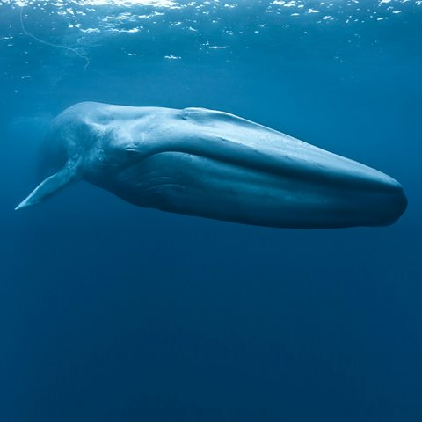
Word Wall
extinct

e
endangered
gargantuan size
lifespan
surfaced
baleen
breach
krill-loving
communicate
migratory
blue whale
cetacean
body parts
ocean-going giant

