Learning Objective
We are learning how to use the perfect form of verbs.

Challenge 1
Decide if the following sentences are in the simple past tense, the present perfect form or the past perfect form.
- The jellyfish paralysed the small fish with its numerous stinging cells.
(simple past/present perfect/past perfect)
- The jellyfish had drifted for many months and was now washed up on the beach.
(simple past/present perfect/past perfect)
- The jellyfish released a cloud of sticky mucus into the sea.
(simple past/present perfect/past perfect)
- The turtles had been watching the sunbathing jellyfish with great interest.
(simple past/present perfect/past perfect)
- She had just finished filming the turtles when something in the water caught her eye. (simple past/present perfect/past perfect)
- There have been many sightings of cassiopeia jellyfish in the Atlantic Ocean.
(simple past/present perfect/past perfect)
Challenge 2
Copy and continue the following past perfect tense sentences to show what happened after the main action/event took place.
1) The jellyfish had already sunk to the bottom of the ocean by …
2) Shortly after Cassius had arrived at the sunbathing party, …
3) Sadly, the jellyfish had died two weeks ago, and …
4) After she had watched the fascinating clip on the cassiopeia jellyfish …
5) The algae had grown all over the jellyfish’s body …
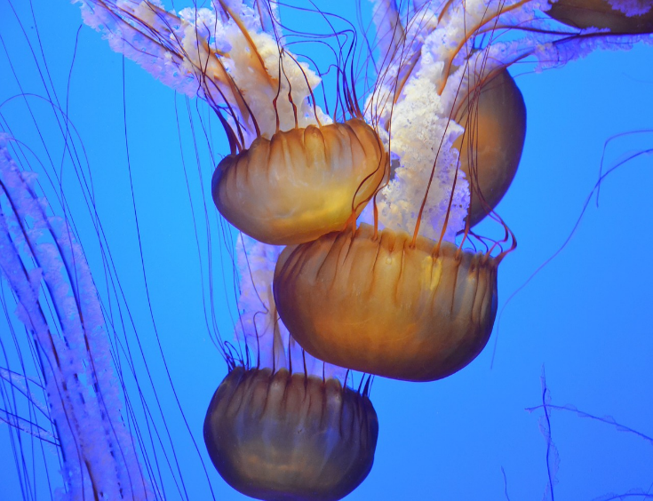
Challenge 3
mobile greenhouse
nutrients
stashed
translucent
algae
tentacles
clustered
Atlantic Ocean
Cassiopeia jellyfish
Imagine that you are a marine biologist. You have just returned from a diving expedition, where you witnessed the remarkable behaviour of cassiopeia jellyfish in the Atlantic Ocean. It’s time to write a diary entry about your encounter with these captivating creatures. Your diary entry must include the following features:
- At least one sentence that uses the present perfect form
- At least one sentence that uses the past perfect form
- Four or more words from the Word Wall
- At least one example of figurative language
solar-powered
Word Wall

