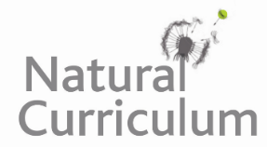
Learning Objective
We are learning how to use the first three or four letters of a word to check its meaning and spelling in a dictionary.

Challenge 1
Match the words with the correct definitions using a dictionary to support you.

reptile (verb) sitting or lying in the sun
dominant (adj) lower in rank or position
sunning (n) a vertebrate animal distinguished by dry, scaly skin
subordinate (n) an animal or person that eats both plants and animals
omnivore (adj) having power and influence over others

Challenge 2
Put the following animals in alphabetical order. You may need to look at the second, third and fourth letter of each word.
lizard
leopard
lamb
lemur
lynx
ladybird
lobster
llama

Challenge 3
Create your own glossary using the words highlighted in the sentences below. Remember that a glossary is like a mini-dictionary for technical words found at the back of information books.

The dominant agama lizard’s magnificent colours were envied by all of his subordinates. As he strutted across the rocky desert area that they inhabited, it was clear to everyone that he thought he was the supreme leader of their group. One young agama lizard felt particularly deflated that he would never be as colourful or majestic as the dominant lizard. However, an older, more mature agama lizard reminded him of all his strengths: his agility, his determination and his courage. The young agama lizard became overwhelmed with pride, not just for himself, but for all the agama lizards that shared his desirable traits.

Here is an example of a glossary for some of the words that were on the Word Wall:
Glossary
bounded - walked or ran with leaping strides.
slumber – sleep.
unwavering – steady or resolute.

