Learning Objective
We are learning how to use hyphens to avoid ambiguity with word meanings.

Challenge 1
Complete the sentences below with the most suitable hyphenated words from the following list:
deep-sea
steel-plated
pitch-black
re-formed
world-famous

thick-bodied
cold-blooded
razor-sharp
sky-blue

- There was no denying that the copper sharks were _____________ killers.
- Tarpon are _____________ fish with large scales that look like a coat of __________ armour.
- At the surface, the sea was _____________ , but deep down it was ____________ .
- The _____________ ______________diver was signing copies of his autobiography.
- The shoal of grey mullet _______________ and continued their migratory journey along Florida’s coastline.
- Though small, the tarpon’s teeth were __________________ .

Challenge 2
Correct the sentences below by joining the words that require a hyphen between them.

- The water turned blood red following the feeding frenzy.
- The long beaked pelicans dive bombed into the Gulf of Mexico
- The state of the art underwater camera captured some amazing footage of the shoaling mullet.
- The surfer re entered the sea in the hope that he would catch a glimpse of the fast moving mullet.
- The cameraman counted twenty four copper sharks circling the tightly packed shoal of grey mullet.
- The young ocean going tarpon was too late to catch any of the action and returned to his family empty handed.
Challenge 3
Imagine that you were one of the surfers in the main clip, who found themselves in the middle of the grey mullet feeding frenzy. Using the Word Wall to help you, write about your once-in-a-lifetime encounter, using Show Not Tell, figurative language and a generous handful of hyphenated words.

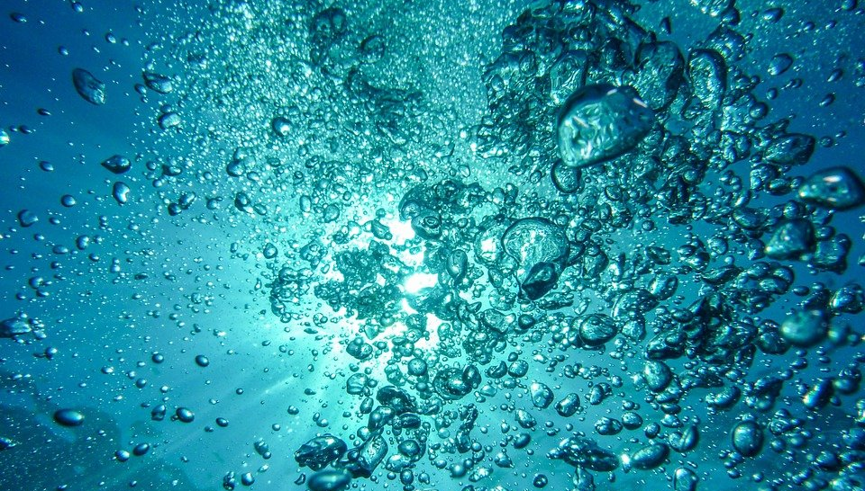
Word Wall
re-entered
blood-red
fast-moving
Florida
tarpon
pelican
grey mullet
blacktip shark
eye-catching
re-discovered
long-beaked
quick-witted
cold-hearted
re-created

