Learning Objective
We are learning how to use relative clauses beginning with who, which, where, when, whose, that or with an implied (i.e. omitted) relative pronoun.

Challenge 1
Read the sentences below. Underline the noun that is being described further with a relative clause. Highlight the relative clause (including the punctuation) and circle the relative pronoun.

- The pumas, who are sisters, crept up slowly towards the guanaco.

- As it stared across the hills, the guanaco, who was getting suspicious, let out a nervous whinny.

- She was furious at her sister, who always messes up her hunting by being too quick and careless, because now they would be hungry yet again.

- Patagonian pumas are loved by tourists and photographers and hated by farmers, who feel the pumas threaten their livestock.

Challenge 2
Match the noun phrase to a suitable relative pronoun and relative clause from the table below.
Write your choices as sentences – remember the punctuation!

noun phrase | , | relative pronoun | relative clause | , | ending for main clause
One of the pumas |  | which | are the largest species of its kind |  | moved too quickly.
The tree-less landscape |  | whose | is rocky, dry and sandy |  | Can grow up to 2.5m long.
These large cats |  | who | tail had never grown |  | gives no cover.
Patagonian pumas |  | that | hunt early morning or at dusk |  | are a protected species.

Challenge 3
Using some of the words form the Word Wall, write your own sentences about the Patagonian pumas that you saw in the clip. Try to include several sentences that feature a relative clause, and experiment with using a range of relative pronouns, both written and implied (omitted). Also, experiment with the position of each relative clause so that they appear both in the middle and at the end of your sentences.

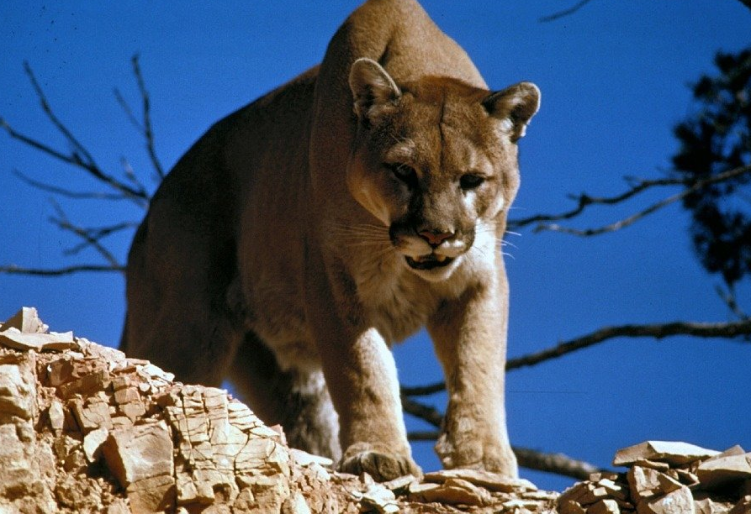
Word Wall
nervous
stealthily
bated breath
dusk
guanaco
puma
grazing
Patagonia
rugged
llama-like
watchful
muscular
mountainous terrain
cautiously

