Learning Objective
We are learning how to use bullet points consistently.

Bullet points are used to help the reader locate information quickly and precisely, especially when there is a lot of complicated information to be understood. Most commonly they break down information into lists of items or key points

Challenge 1
Think back to the generally agreed conventions for using bullet points. With a talk partner, see if you can identify the mistakes that have been made for each of the bulleted lists below and use your editing skills to make any necessary corrections.

1)  The diet of a king penguin includes the following foods  - Small fish  - Luminescent lantern fish  - Squid  - Crustaceans | 2)  King penguins can be found on the following sub Antarctic islands:  - crozet island (in the southern Indian Ocean)  the kerguelen islands also known as the desolation islands.  - prince Edward (a canadian province).  South Georgia (A British Overseas Territory In The Southern Atlantic
3)  Though similar in appearance, king penguins differ to emperor penguins in the following ways  they are smaller.  Their beak is longer and more curved  they have a spoon-shaped orange patch on their head, which is much darker in colour | 4)  Here are some things that king penguins can do to raise their young successfully:
Challenge 2
Using your newly-acquired knowledge of the king penguin, write a short information report about this remarkable species that uses a range of presentational devices such as headings, sub-headings, bullet points, fact boxes and tables. See if you can include some of the words from the Word Wall in your report.
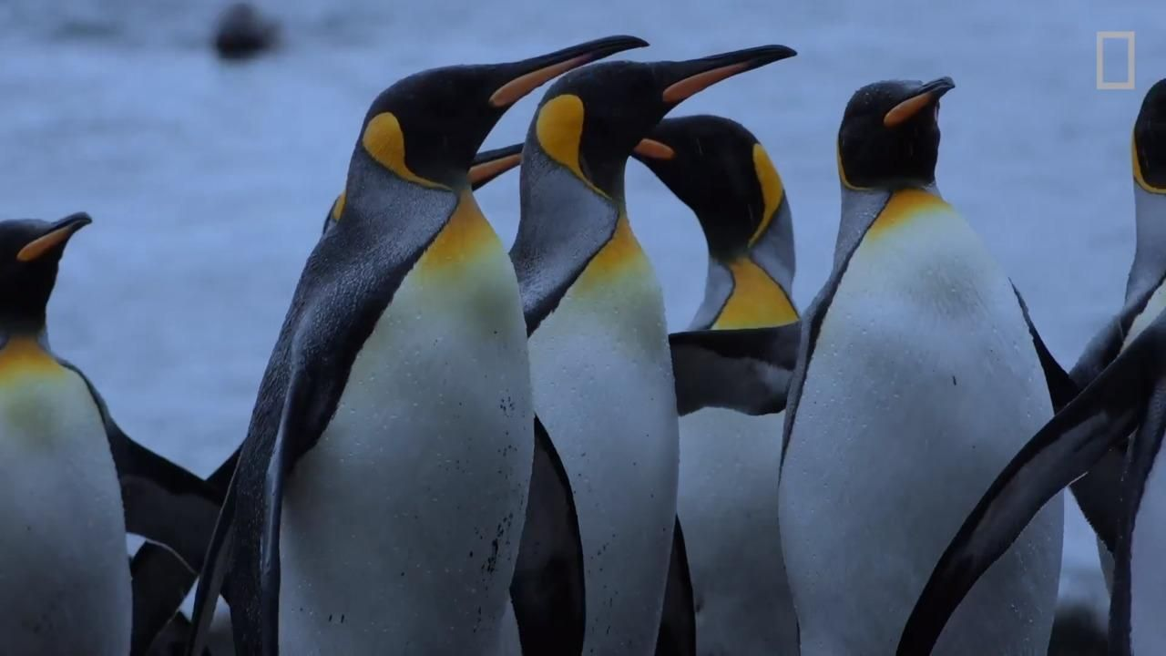
Word Wall

harsh
teamwork
nurturing
breed
regurgitate
thrive
Antarctica
predators
giant petrel
sheathbill
king penguin

