Learning Objective
We are learning how to write sentences that use a semi-colon to mark a boundary between two main clauses.

Challenge 1
Decide where you think the semi-colon should go in each of the following sentences.

- The leopard seal’s body is sleek and smooth this allows it to move swiftly through the water.
- Leopard seals are members of the seal family they are the only member that regularly eats warm-blooded animals.
- Leopard seals are known for hunting penguins however, they commonly prey on krill, shrimps and shellfish.
- These animals enjoy periods of rest they do this by hauling out on to ice floes.
- Leopard seals commonly wait underwater near an ice shelf this enables them to catch penguins as they dive into the water.
- The leopard seal is known for its striking coat fortunately it is not commercially hunted for it.
- Leopard seals have evolved to survive in the icy Antarctic waters they do this by having a thick layer of insulating fat called blubber.
- Despite being formidable predators, climate change is impacting on leopard seals the decreasing ice means they struggle to find prey.

Challenge 2
Complete the following sentences with a second main clause after the semi-colon. This clause should express a complete thought. It should also relate closely to what has been stated in the first main clause.

- The penguin was all too well aware of the seals presence; …
- The leopard seal relentlessly pursued the penguin; …
- The leopard seal curled its streamlined body towards the fleeing penguin; …
- The seal dived deep below the ice without a sound; …
- The leopard seal’s coat is spotted, similar to a leopard itself; …

Challenge 3
Focusing on the first chase until the point where the penguin lands safely back with the others, create a dramatic piece of descriptive writing for children who might have visual impairments. How will you bring the chase to life for them? Describe both animals, the sounds and use a range of adverbs to describe their movements.
Try to include a range of sentence types and punctuation marks that include semi-colons. Try also to use some of the descriptive words from the Word Wall.

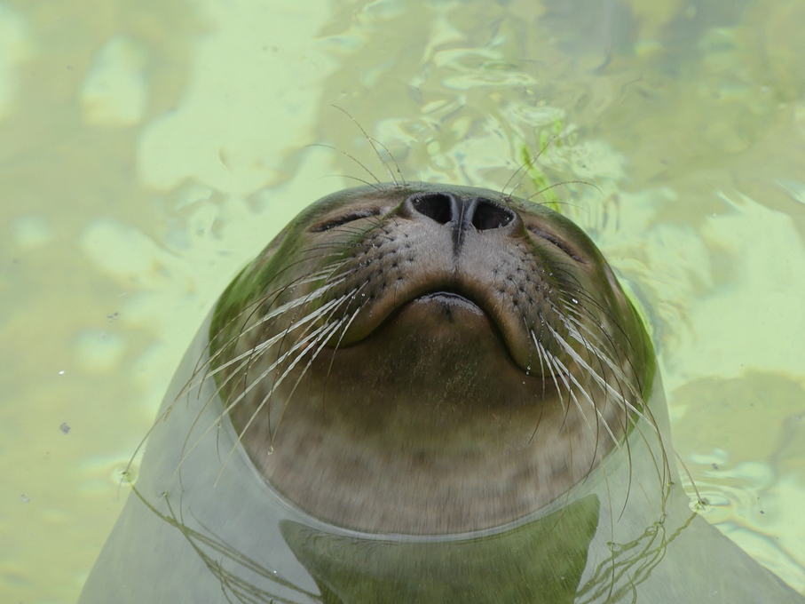
sleek
intrepid
relentlessly
powerful, vicious jaws
Antarctic wilderness
tiring
exhausted
muscular, streamlined body
snout
casually
penguin
leopard seal
Word Wall

