Learning Objective
We are learning how to write sentences that include modal verbs and adverbs to show degrees of possibility.

Challenge 1
Highlight the modal verb in each of these sentences, and put them in order from the most likely to happen to the least likely to happen. The first has been done for you.

1
Magellanic penguins must be able to tolerate cold temperatures underwater.
Magellanic penguins might occasionally raise just one chick.
Magellanic penguins can live for up to 30 years in captivity.
Magellanic penguins should hunt in flocks in order to be successful predators.
Magellanic penguins will usually live for up to 25 years in the wild.

Challenge 2
Complete the paragraph by filling in the gaps with combinations of appropriate modal verbs and modal adverbs.
Modal verbs: can, could, might, must, would, should, ought to, may, shall, will
Remember that many modal verbs can also be used in their negative form.
Modal adverbs include usually, probably, possibly, always, occasionally, surely, always, generally, often, never, certainly, perhaps, definitely, normally.

Magellanic penguins __________________ be found in the waters off the coast of southern South America. Although they are used to low temperatures, these fascinating creatures ________________ can be found in the warmer waters off the Brazilian coast. They __________ congregate in large flocks, eating cuttlefish, squid and krill, although they __________________ bring up their young in pairs. The females _________________ lay their eggs in warm places. The male and female penguins in these pairs ____________ take turns hatching as the other forages for food. There are ______________ two eggs and the second egg is _________________ larger than the first. Magellanic penguins ____________ stay with the same partner year after year. Magellanic penguins are among the many species of penguin facing serious threats to their survival, including chronic oil pollution, drowning in fishing nets and climate change. If action isn’t taken now, this incredible species ___________________ become extinct.

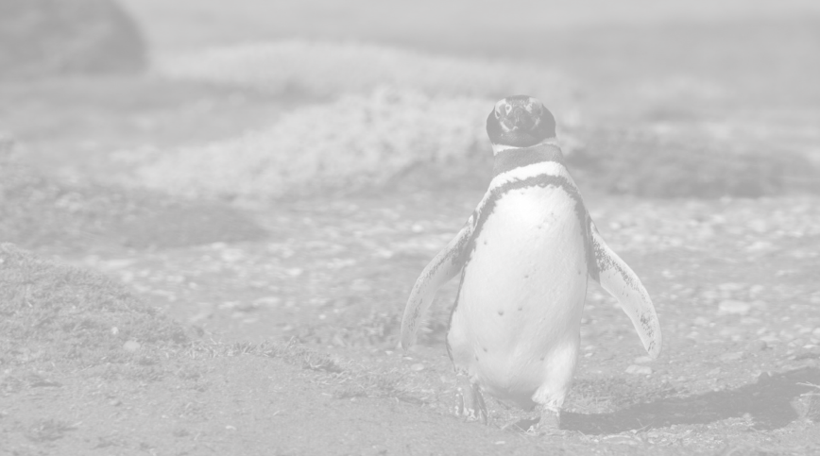
Challenge 3
Write your own short article about the remarkable story of friendship between Joao and Jinjing for the Brazilian newspaper - the Rio Times.
Try to include as many modal verbs, modal adverbs and descriptive words from the Word Wall.
Word Wall

could
must
can
might
occasionally
certainly
often
usually
bond
reunited
devoted
Patagonia
Rio De Janeiro
sardines
inseparable

