Learning Objective
We are learning to use expanded noun phrases to convey complicated information precisely.

Challenge 1
Highlight the expanded noun phrases in the paragraph below:

Sparrowhawks prefer to nest in areas of dense woodland. They are specialist hunters of birds; more than 120 species have been recorded as prey, ranging in size from the teeny-tiny goldcrest to the large chicken-like pheasant. In recent years, their hunting ground has widened to include densely populated towns and cities, where songbirds are frequent visitors to gardens and parks. They prefer to make their surprisingly large nests, which are a messy bundle of sticks, in forested areas, parks and large gardens. In these ramshackle nests that can measure up to 60cm, they lay four to six pale blue and brown speckled eggs. They live across temperate areas of Europe, Asia and northern Africa and unlike other northern-dwelling birds, they do not migrate to the warmer south for the winter.

Challenge 2
Read the passage below. It has lots of simple noun phrases. Expand the simple noun phrases by adding an adjective in front of the noun as well as adding some prepositional phrases and relative clauses to make the passage more interesting to read.

Sparrowhawks are one of the most ___________ birds of prey in the United Kingdom. The ___________ males have a __________ back with _______________________________ underneath. By contrast, the bigger females are recognisable for their _______________ plumage. Flying at speeds of up to 50kph, these ____________ , __________ raptors are able to strike in just four seconds. They use their __________, _________ wings, which ____________________________________ , to power themselves forwards. Their _______________ tail, which ________________________________ , enable them to make precise movements in the air.

Challenge 3
Write your own David Attenborough-style script to accompany either the main clip (screen 1) or the related clip (screen 4). Try to include some of the words from the Word Wall below and don’t forget to include sentences that contain expanded noun phrases, where there is additional information about the nouns, both before (through adjectives) and after them (through prepositional phrases or relative clauses).

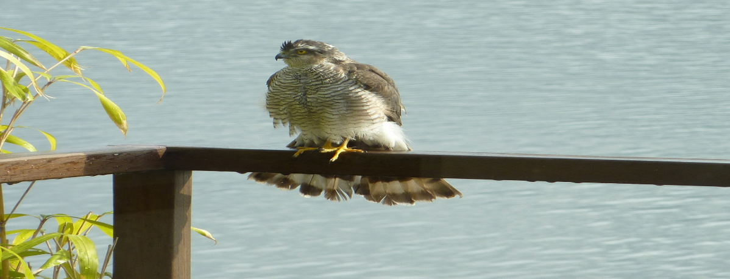
Word Wall

scooped
manoeuvred
agile
fine adjustments
lightweight
aerial assassin
raptor
precision flying
stealthy
explosive acceleration
sparrowhawk

