Learning Objective
We are learning how to proofread for spelling and punctuation errors

Challenge 1
Read the following sentences carefully. Use the CUPS proofreading checklist to identify any errors with capital letters (C), understanding (U), punctuation (P) and spelling (S). Use your editing pen to correct them.

1) Cuttlefish can make themselves look like a sandy seabed a spiny peace off coral or a lump of hard granite rock

2) To escape from the predators the cuttlefish used there colour-changing powers?

3) Are you aware that these higly inteligent marine invertebrates have an internal shell called a cuttlebone that is used to control the creature s buoyancy.

4) Allthough crabs have sharp claws. They can overcome them by hypnotising them.

Challenge 2
Highlight the 10 spelling mistakes and 5 punctuation errors in the paragraph below and then use your editing pen to make any necessary corrections
Top Tip – Reading the sentences out loud will help you spot punctuation mistakes and reading sentences backwards may help you spot spelling mistakes.

Did you know that cuttlefish aren’t fish They are in fact molluscs a family that includes squid octopuses and nautiluses. Thay can grow up to about 45cm long and life for up to two years. Thay are fierce predators. They has a special skin pigmentation (which enables them to change colour. They can use this color changing ability to hypnotises they’re prey or camouflages themselves when threatened

Challenge 3
Using the Word Wall to guide your thoughts, write a paragraph about a cuttlefish and its hypnotising super power. Use the CUPS method to proofread your work, and try to include the following grammar and punctuation features to make your sentences more interesting to your reader:

- A relative clause or parenthesis
- A subordinating conjunction
- A colon (for introducing a list)

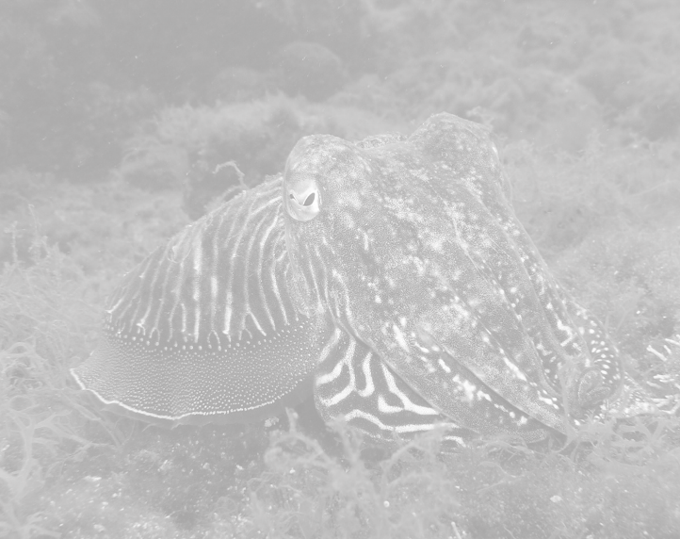
Word Wall

cuttlefish
alien-like
mollusc
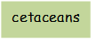
invertebrate
camouflaged
cuttlebone
crab-hunting specialist
pigment
mottled
hypnotic

