Learning Objective
We are learning how to use a colon to introduce a list.

Challenge 1
Correct the following sentences by inserting the necessary punctuation marks.

- There are several oceans in the world that flying fish inhabit the Atlantic Ocean the Pacifc Ocean and the Indian Ocean.
- Flying fish face many predators in both the sea and the sky dolphins dorado fish frigate birds marlin and squid are all known to eat them.
- Flying fish are hunted and consumed in several countries Vietnam Japan and China.
- Many aspects of Barbadian culture centre around flying fish they are printed on coins, they feature in sculptures they are common in artwork and they are part of the official logo of the Barbados Tourism Authority.

Challenge 2
Rewrite each of the sentences below so that a colon introduces the list. Remember – your introductory clause must be able to stand alone as a sentence. Also, when rewriting the sentences, remove the unnecessary ‘ands’ and replace them with the correct punctuation marks.

- On the hunt for flying fish, the frigate bird wheeled above the ocean and used its keen eyesight to detect movement below and swooped low to snatch its prey.
- The flying fish was able to take to the air by angling its body upwards and thrashing its tail from side-to-side and spreading its pectoral fins.
- Flying fish can travel at the speed of 37 miles per hour in the water and they can reach a height of 4 feet in the air and they can glide for a distance of 655 feet.
- The Atlantic flying fish and the California flying fish and the bandwing flying fish and the short-winged flying fish are just some of the 40 known species of flying fish.

Challenge 3
Write a description of the journey the flying fish takes through the skies and waters that lie beneath. Use some of the phrases and words on the Word Wall to help you depict its frightful fight for survival. Make sure two of your sentences use a colon accurately to list information about the creature.
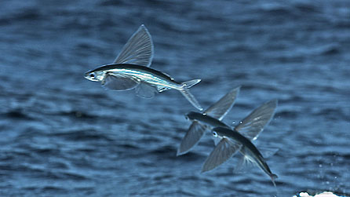
Word Wall

lift
vibrating tail fin
deep blue sea
wing-like pectoral fins
streamlined body
dorado fish, sea lions, frigate birds, dolphins
predator race
modified fins
airborne

