Learning Objective
We are learning how to use the perfect form of verbs.

Challenge 1
Decide if the following sentences are in the simple past tense, the present perfect form or the past perfect form.
- The camera traps captured the grizzly bear scent marking the tree trunk.
(simple past/present perfect/past perfect)
- In the depths of the thick forest, the Planet Earth II team hid the camera traps.
(simple past/present perfect/past perfect)
- The bear had left its scent mark, posting its presence for other bears to sniff out. (simple past/present perfect/past perfect)
- With food in short supply, the bears have begun their hibernation period.
(simple past/present perfect/past perfect)
- On the river bank, the grizzly bears gorged themselves on salmon.
(simple past/present perfect/past perfect)
- By late spring, the bears had shed their shaggy winter coats.
(simple past/present perfect/past perfect)
Challenge 2
Copy and continue the following present perfect form sentences, showing how a past tense action or event is connected in some way to the present.
e.g. The bears have lived …
The bears have lived in this forest all of their lives.

1) Twigs and leaves have attached …
2) The cubs have grown up and …
3) The bears have disappeared …
4) The female grizzly has forgotten …
5) “Where have you … ?”
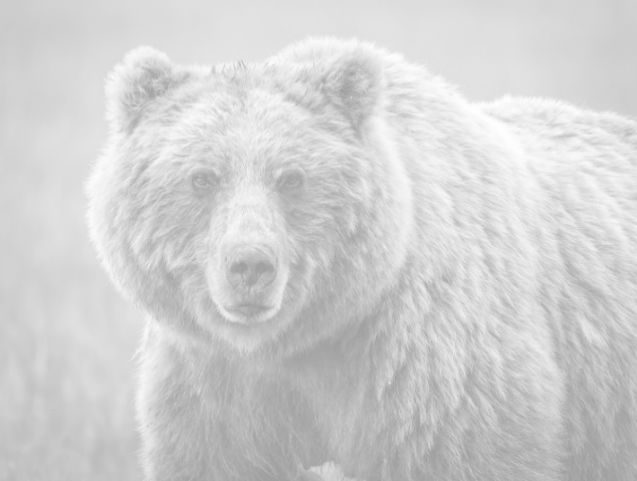
Word Wall
imitate
territory
grizzly bear
communicate
unbearable itch
scent mark
hibernation
groovy
comical
Yellowstone National Park
Challenge 3
Imagine that you were the cameraperson responsible for setting the camera traps that captured the incredible back-scratching grizzlies on film. Write about what your cameras showed and how you felt in a diary entry. Your entry should include the following:
- At least one sentence that uses the present perfect form
- At least one sentence that uses the past perfect form
- Four or more words from the Word Wall

