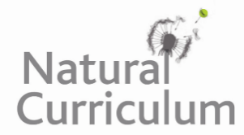
Learning Objective
We are learning how to use hyphens to avoid ambiguity with word meanings.

Challenge 1
Complete the sentences below with the most suitable hyphenated words from the following list:
brightly-coloured
small-sized
insect-hunting
peacock-like

tree-leaping
leg-waving
co-operate
nimble-footed
cold-hearted

- The______________ spider leapt out of the way of the attacking female.
- Although in danger, the male spider started an enthusiastic _____________ dance to try and impress the female.
- The male raises its ______________ tail to impress the female.
- In contrast to the dull female, the male is ______________ .
- The ____________spider has to move quickly to escape the female.
- This spider species does not make a web; it is an _____________ spider.
7) The __________________ display failed to impress the ______________ female, though she was more willing to ____________________ with his plan when he performed his dazzling display a second time.

Challenge 2
Correct the sentences below by joining the words that require a hyphen between them.

- Although it is a teeny tiny arachnid, the peacock jumping spider is nimble footed, quick jumping, fast moving and agile.
- On the top of their scary looking heads, jumping spiders have two medium sized eyes and two smaller eyes.
- The ability to leap distances of over thirty five centimetres helps this insect hunting arachnid catch mouth watering prey.
- The ant mimicking spider is a species of jumping spider that is the master of disguise.
- If the cold hearted female does not like the look of the crazy dancing male, she may decide to eat him.
- Males have to be brave and persistent to impress their female eating partners.
- These woodland dwelling creatures are thought to be under threat due to habitat destruction.
- The arachnologist counted thirty five jumping spiders in the broad leaved forest.
Challenge 3
Write your own narration for the main clip in the style of David Attenborough. It should include some figurative language, factual information about peacock jumping spiders, elements of suspense and a generous handful of hyphenated words. You may find some of the words in the Word Wall helpful when completing this writing challenge.
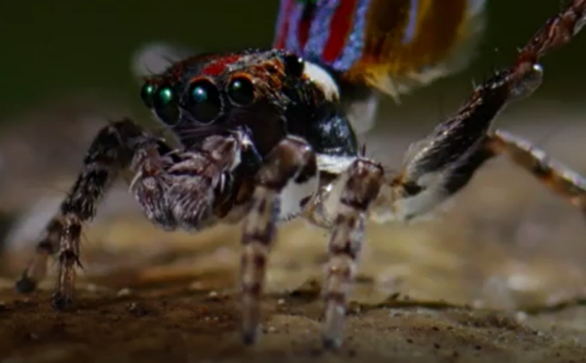
ambushed
sure-footed
re-covered
arachnid
unfurled
bad-tempered
Bad-tempered
striking fan
elaborate colours
Word Wall
Challenge 3
Write your own narration for the main clip in the style of David Attenborough. It should include some figurative language, factual information about racoons, elements of suspense and a generous handful of hyphenated words. You may find some of the words in the Word Wall helpful when completing this writing challenge.
raccoon
raccoon
Word Wall
raccoon
raccoon
Word Wall
Challenge 3
Write your own narration for the main clip in the style of David Attenborough. It should include some figurative language, factual information about racoons, elements of suspense and a generous handful of hyphenated words. You may find some of the words in the Word Wall helpful when completing this writing challenge.
Challenge 3
Write your own narration for the main clip in the style of David Attenborough. It should include some figurative language, factual information about racoons, elements of suspense and a generous handful of hyphenated words. You may find some of the words in the Word Wall helpful when completing this writing challenge.

