
Learning Objective
We are learning how to use figurative language.

Challenge 1
Copy and complete the following sentences. Will you make them the same as the sentences that were modelled in the lesson, or will you make them different? For each sentence, the figurative device that you need to consider is indicated inside the brackets.

1) The rush of wind _______________________ her feathered cheeks as she started to gather speed. (personification)
2) Like a____________________________ , the majestic whooper swan took to the air. (simile)
3) Shrouded in an eerie mist, the ______________________ glided silently across the glassy lake. (metaphor)

Challenge 2
Using your knowledge of the whooper swan featured in the film clip, or swans in general, copy and complete the following sentence openers using the figurative language device indicated inside the brackets.

1) The swan held her head high ________________________________________ (simile)
2) Drifting across the glassy lake, the ________________________________ (metaphor)
3) Casting shadows over the lake, the clouds ________________________ (personification)
4) Her feathers were soft to the touch, like ____________________________ (simile)
5) Flying at an altitude of 8,000m, the _______________________________ (metaphor)
6)) The elegant swan _________________________________________ (personification)
7) The swan craned her neck forwards like ________________________________ (simile)
8) After leaving her watery runway far behind, the _____________________ (metaphor)

Stretch activity: For each sentence above, give some additional information/detail about each underlined noun by including a parenthesis or a relative clause.

Challenge 3
Imagine that you are rowing your boat on a beautiful Scottish loch (lake), fringed by magnificent mountains. All of a sudden, the peace and tranquillity is disrupted by the ‘whoop whoop’ sound of a whooper swan as it takes to the air just metres away from you. Write a detailed diary entry of this encounter that includes examples of simile, metaphor, personification and some of the words from the Word Wall.
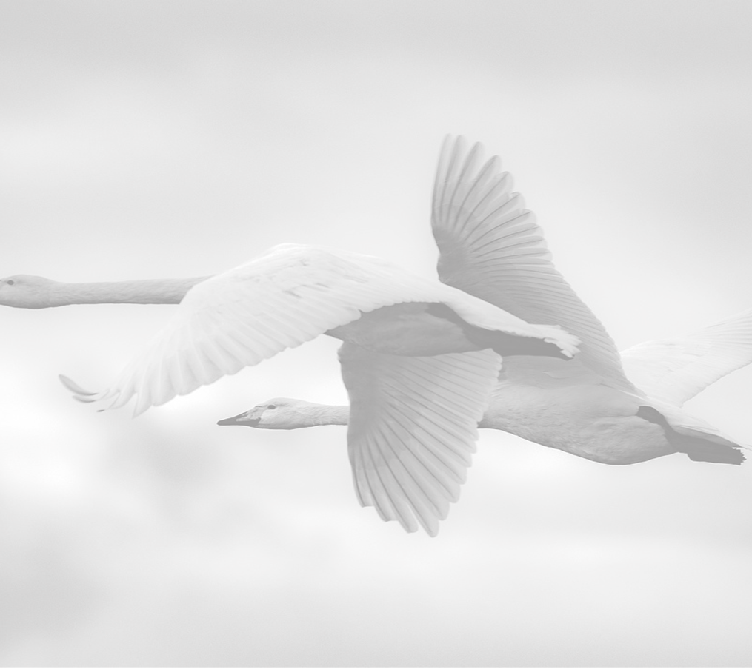
Word Wall
whooper swan
elegant
migrating
powered
snake-like neck
webbed feet
snow-white plumage
accelerated
raucous
gravity-defying
lift

