Learning Objective
We are learning how to write sentences about chimpanzees that contain possessive apostrophes.

Challenge 1
Decide where the apostrophes should go in the following sentences:
- Africas tropical forests and grasslands are where its chimpanzee population can be found.
- The great apes hands had opposable thumbs that were similar to those of a human.
- The chimps deaths were caused by a disease that they caught from a human.
- As the rain lashed down, the chimpanzee prodded the termites nest with a stick.
- The poachers cage contained several baby chimpanzees.
- The BBCs undercover investigation led to the rescue of a one-year-old chimp, who was being kept as a pet.
- A fully grown chimps strength is six times the strength of a human.

Challenge 2
See if you can rewrite the following sentences so that they each contain a possessive apostrophe:

- The long black hairs, which belonged to the pair of angry chimps, were standing up on-end.
- The shells, which belonged to the kola nuts, were extremely hard to crack.
- The laughter, which belonged to several young chimps, showed that they were enjoying each other’s company.
- The seven-year-old, who belonged to the protective mother, couldn’t crack open the nut.
- The chimp population, which belongs to Central Africa, must be protected from illegal poaching.
- The discoveries, made by Dr Jane Goodall, have led to a much greater understanding of chimp behaviour.
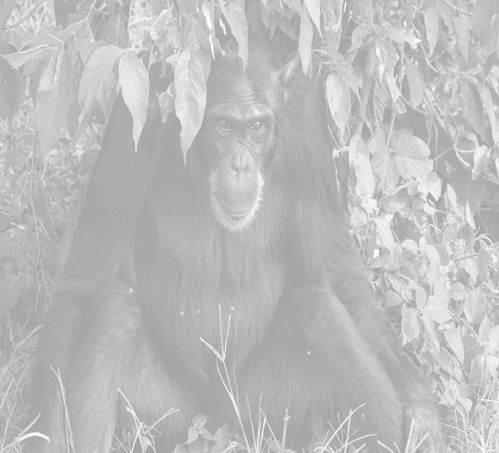
Word Wall
protective
rainforest
undergrowth
wielded
hammered
rummaged
brittle
cumbersomee
human-like
perfected
mastered
intelligent
chimpanzee
Challenge 3
Take one of the sentences that you have written today and write 5 or 6 new sentences that follow on from it. Try to include some more sentences that require possessive apostrophes for both singular and plural nouns. See if you can include some of the descriptive words from the Word Wall.

