Learning Objective
We are learning how to write sentences about snow leopards that include modal verbs to show degrees of possibility.

Challenge 1
Complete the following sentences with an appropriate modal verb from the following list: will/won’t, would/wouldn’t, should/shouldn’t, could/couldn’t, may, can/cannot, shall/shan’t, ought to/ought not to, must/mustn’t, might and might not.

- “The snow leopard __________ be far away as I can smell its pungent scent marks.”
- When hungry, a snow leopard ________ sometimes kill an animal that belongs to a farmer such as a sheep or a goat.
- All governments __________ put a ban on the sale of products that are made from snow leopard body parts.
- “We ___________ have to kill this snow leopard if it continues to eat our livestock,” said the angry Mongolian goat herder.
- Due to their powerful bodies, snow leopards ___________ scale steep slopes with ease.
- “You ____________ watch the related clip that features Khenrab Phuntsog tracking a snow leopard. It’s fascinating!”
- When resting, a snow leopard __________ wrap its long tail around its body to protect it from the cold.
- The film crew _____________ locate the snow leopard because its footprints were covered up by the recent snowfall.

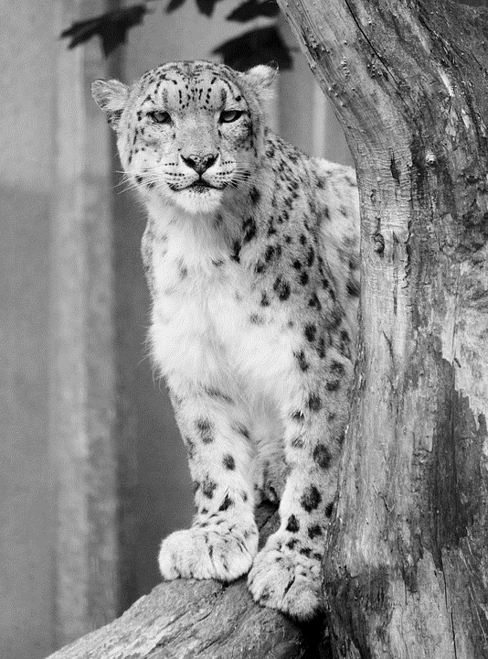
Challenge 2
Create your own sentences about the snow leopard featured in the film clip using some of the modal verbs, modal adverbs and descriptive words from the Word Wall.

Challenge 3
While leading a group of skiers through deep snow in a mountainous region of northern India, you come across a snow leopard. Starting with the following sentence, follow the slow write instructions below, and write about this incredible encounter.

The usually secretive cat appeared to be stalking us.

Sentence 2: This sentence must include a modal verb.
Sentence 3: This sentence must include a list of expanded noun phrases.
Sentence 4: This sentence must include either a relative clause or a parenthesis and two descriptive words from the Word Wall.
Sentence 5: This sentence must be a question that starts with a modal verb.
`
Word Wall
won’t
will
might
never
certainly
definitely
perhaps
must
Himalayas
urine
Snow leopard
roamed
sprayed
scent
could
territory
secretive
pungent

