Learning Objective
We are learning how to write sentences about anglerfish in both the active and passive voice.

Challenge 1
Decide if the following sentences are in the active or passive voice.
- The monstrous anglerfish swallowed the squid whole. (active/passive)
- The slow- moving anglerfish was being followed by the submarine. (active/passive)
- The glowing lure attracted prey from far and wide. (active/passive)
- The female anglerfish was bitten several times by the smaller male. (active/passive)
- The shrimp was ambushed by the monster of the deep. (active/passive)
- The male anglerfish latched onto the female with his razor-sharp teeth. (active/passive)

Challenge 2
Rewrite the following active voice sentences in the passive voice so that the agent of the action (bold) moves to the end of the sentence and the object (underlined) moves to the front (and becomes the subject of the sentence).
- The male anglerfish detected the female.
e.g. The female was detected by the male anglerfish
- The male anglerfish, with needle-sharp teeth, attached itself to the female.
- The team lowered the expensive submarine into the icy water.
- The diver observed the light show from his submarine.
- In a split-second, the frightful anglerfish swallowed the unsuspecting squid.

Challenge 3
Write your own script for Sir David Attenborough to accompany the anglerfish clip that we watched at the beginning of the lesson. See if you can do this as a slow write, following the instructions below:
Sentence 1: Your sentence must be in the active voice.
Sentence 2: Your sentence must include a simile.
Sentence 3: Your sentence must be written in the passive voice.
Sentence 4: Your sentence must include a relative clause.
Sentence 5: Your sentence must include at least 2 words from the Word Wall.

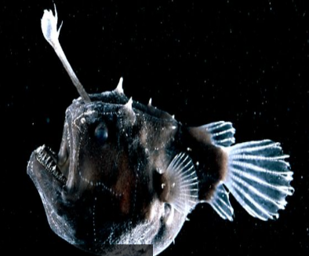
attracted
luminous
Word Wall
anglerfish
terrifying
dark zone
pyrotechnic display
extendable stomach

intrigued
murderous
bacteria-filled lure

